**UI Prototype  
Gudspot**

**Qua Môn**

**1/Search place:**

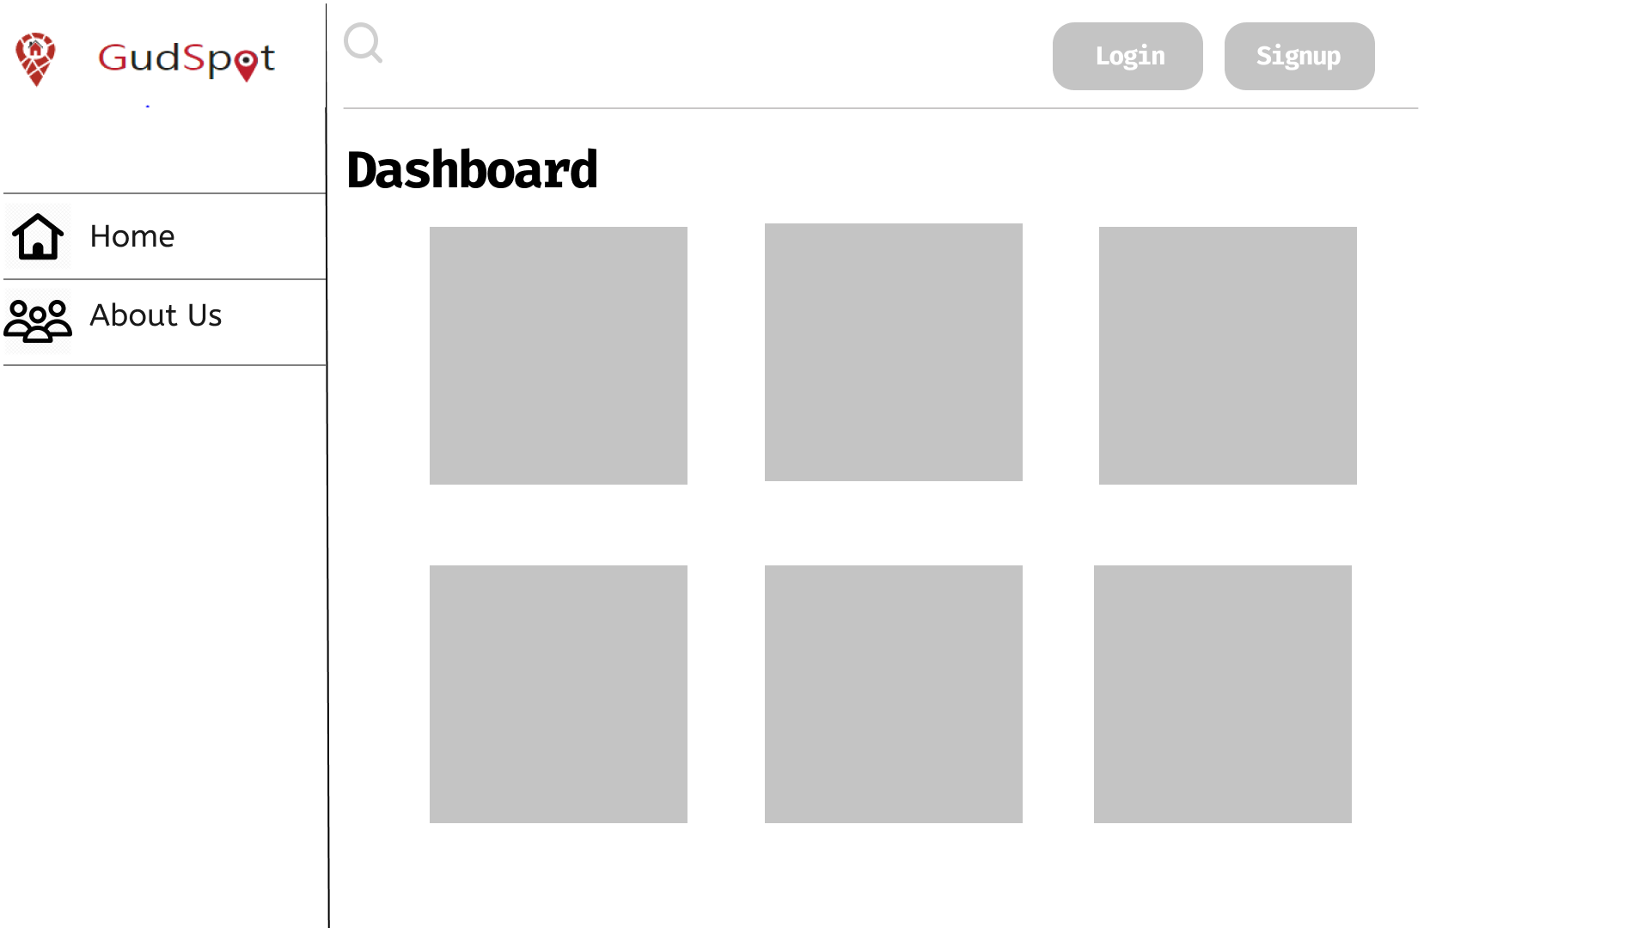

Choose the search bar at the top of the page.

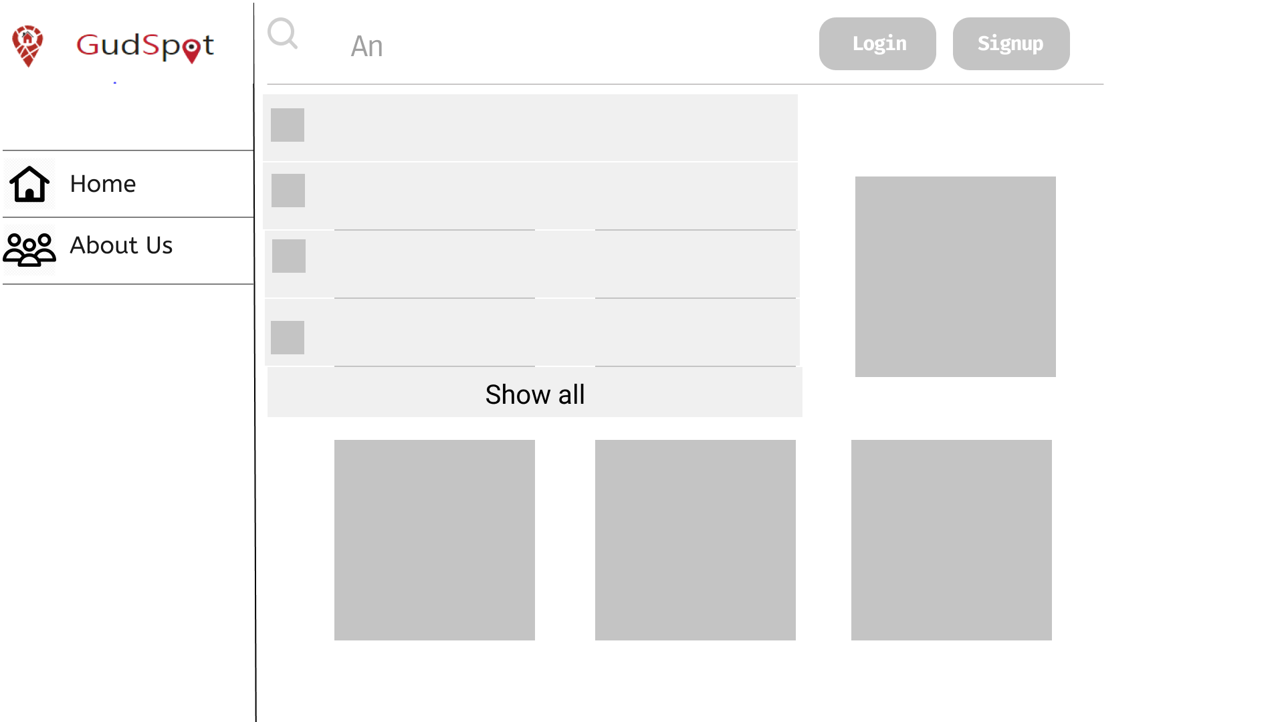

GudSpot shows some of suitable places

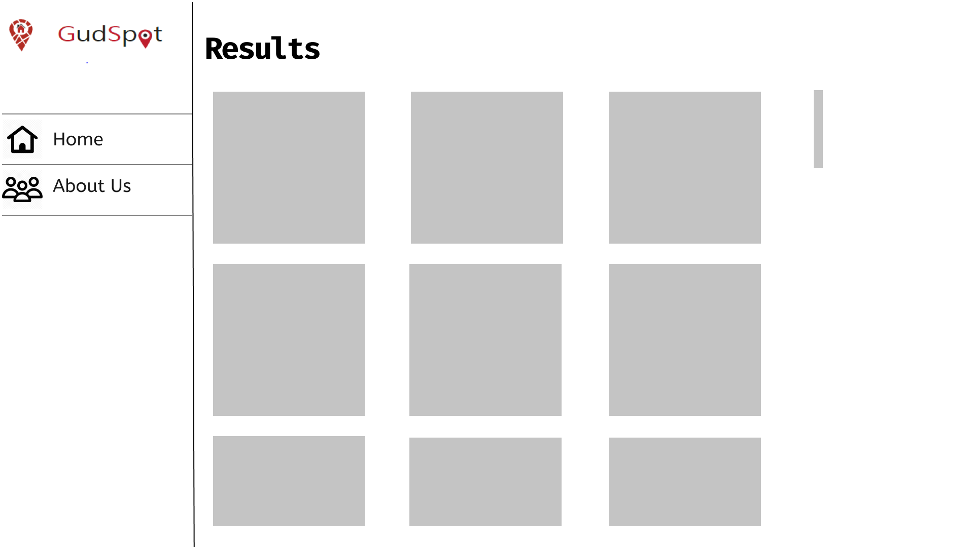

After clicking show all, show all suitable results.

**2/ Recommend place**

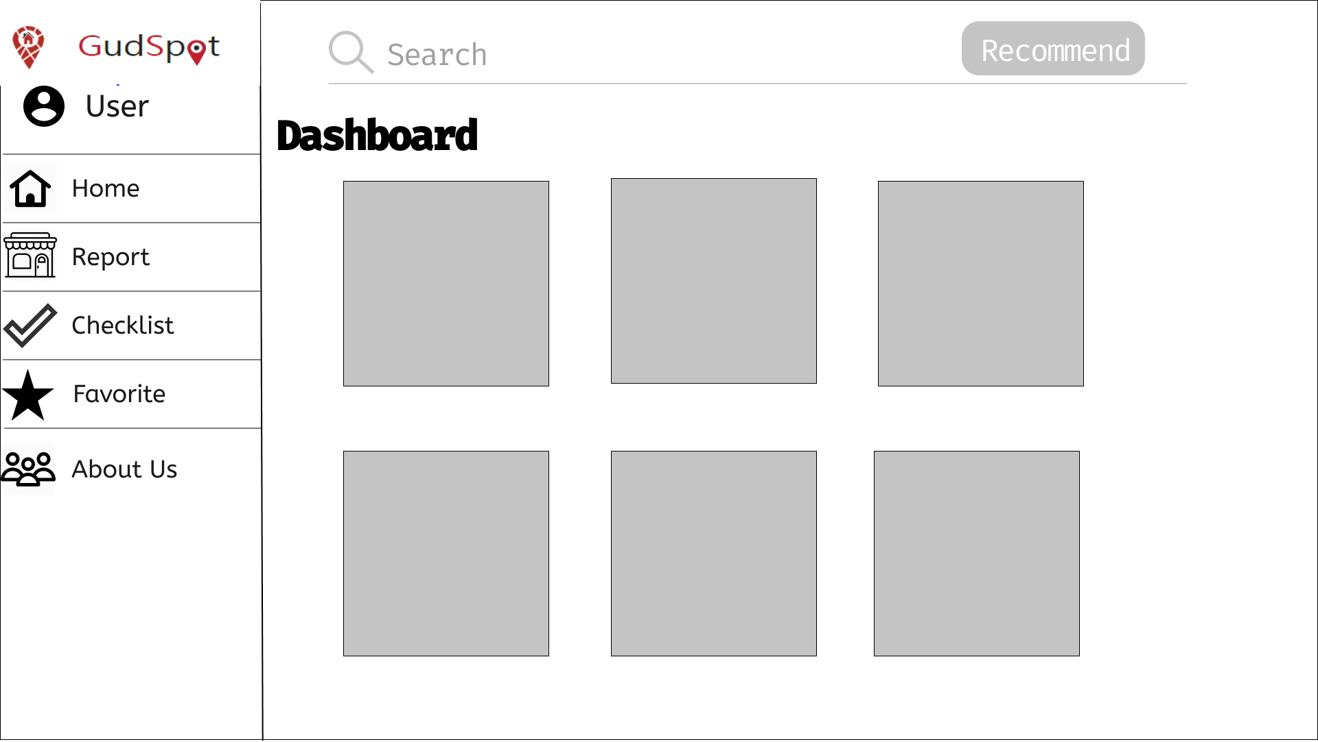

When you sign in and at the main page of Gudspot, at the Search bar, there is a Recommend button. You can click on this button to use Recommend place function

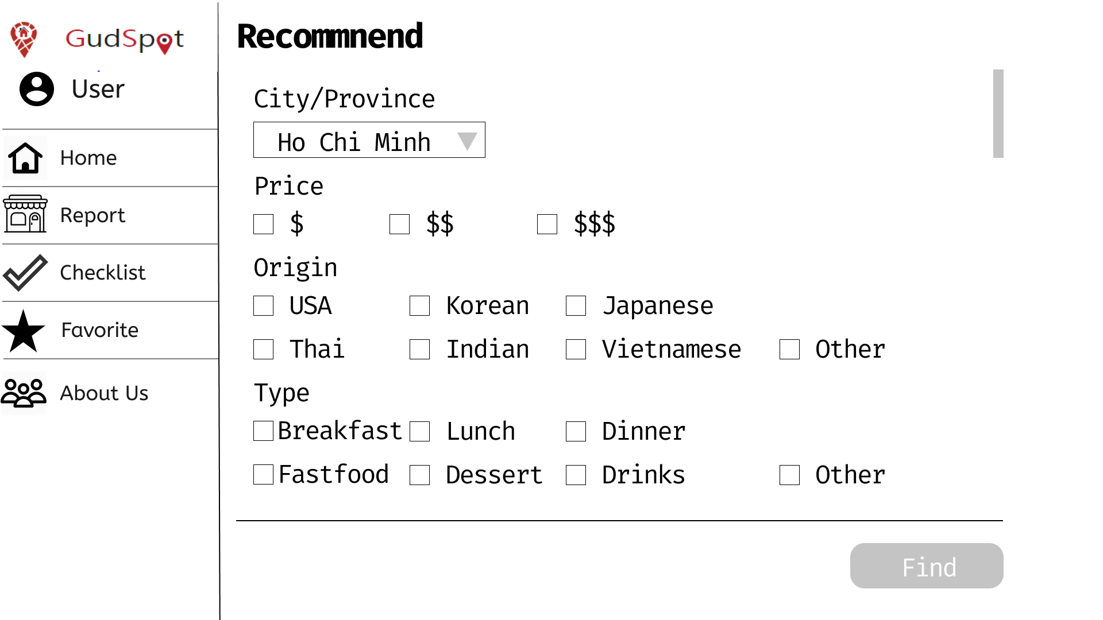

After clicking the Recommend button, you will get to the Recommend page when you can choose different attributes that best describe the place you want to find. Then you click Find.

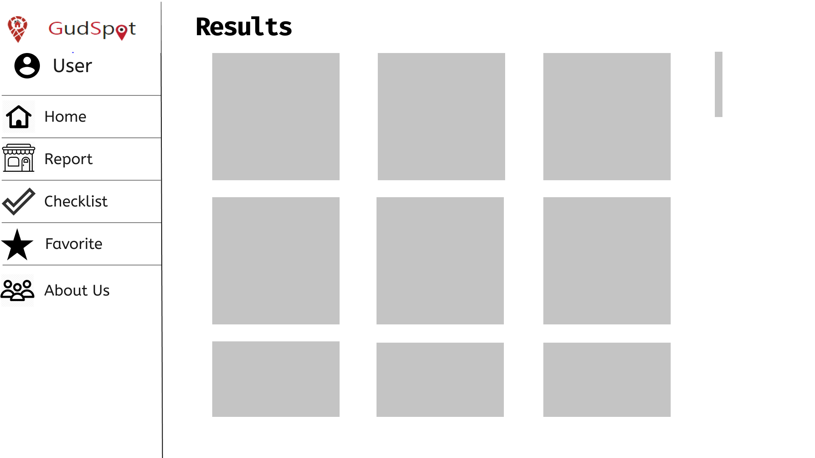

The Results page will pop up and show you some places that are similar to your description.

**3/ Sign up**

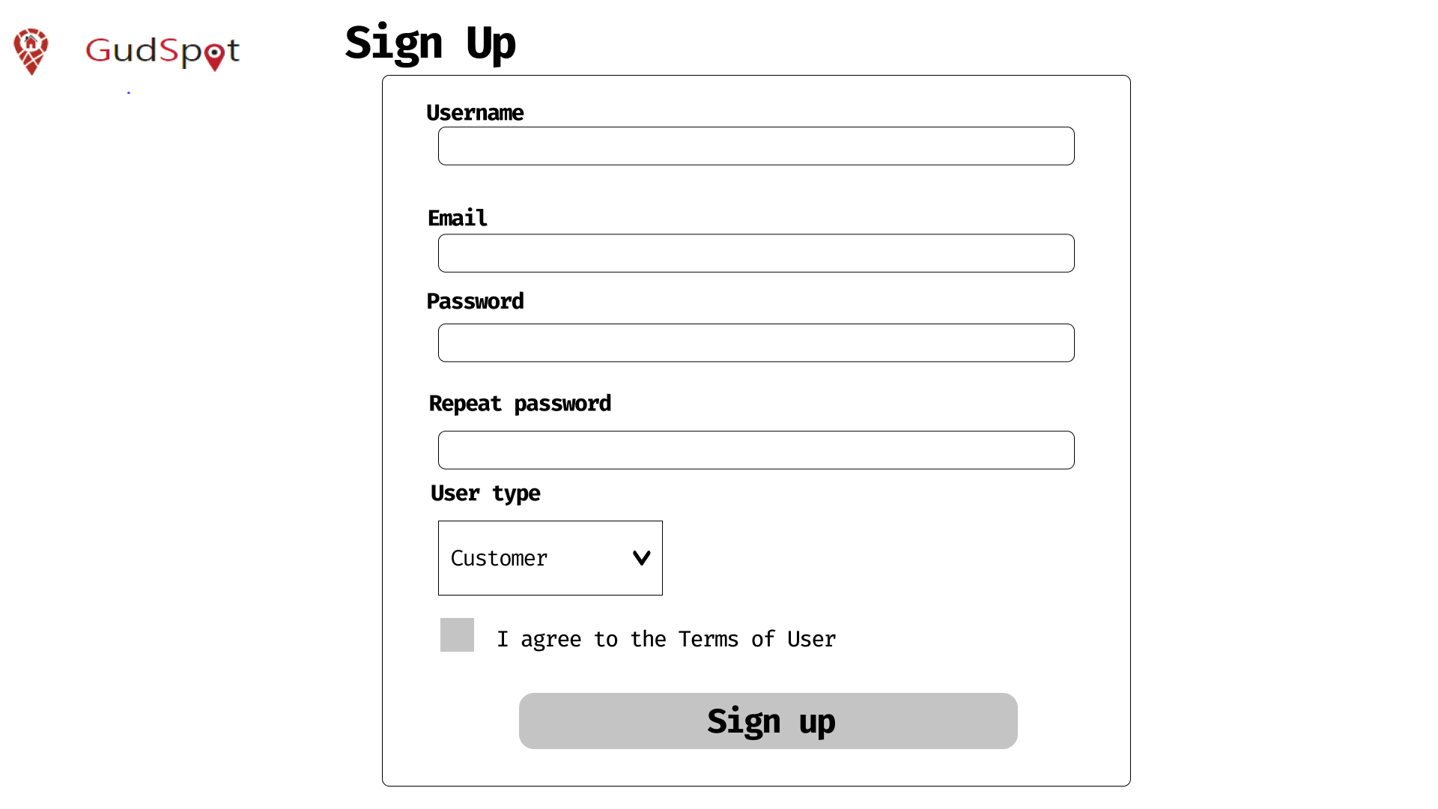

Clicking the signup button at homepage in order to go to sign up page.

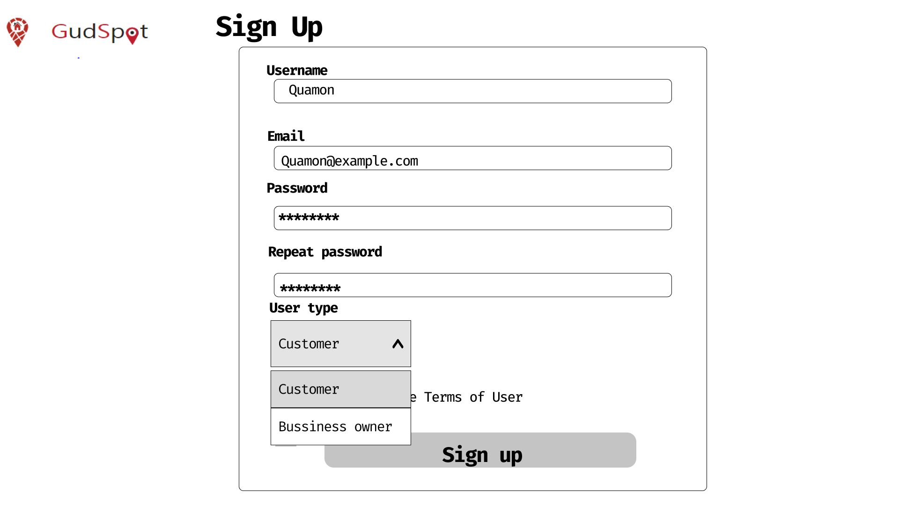

Input all information, choose user type if needed.

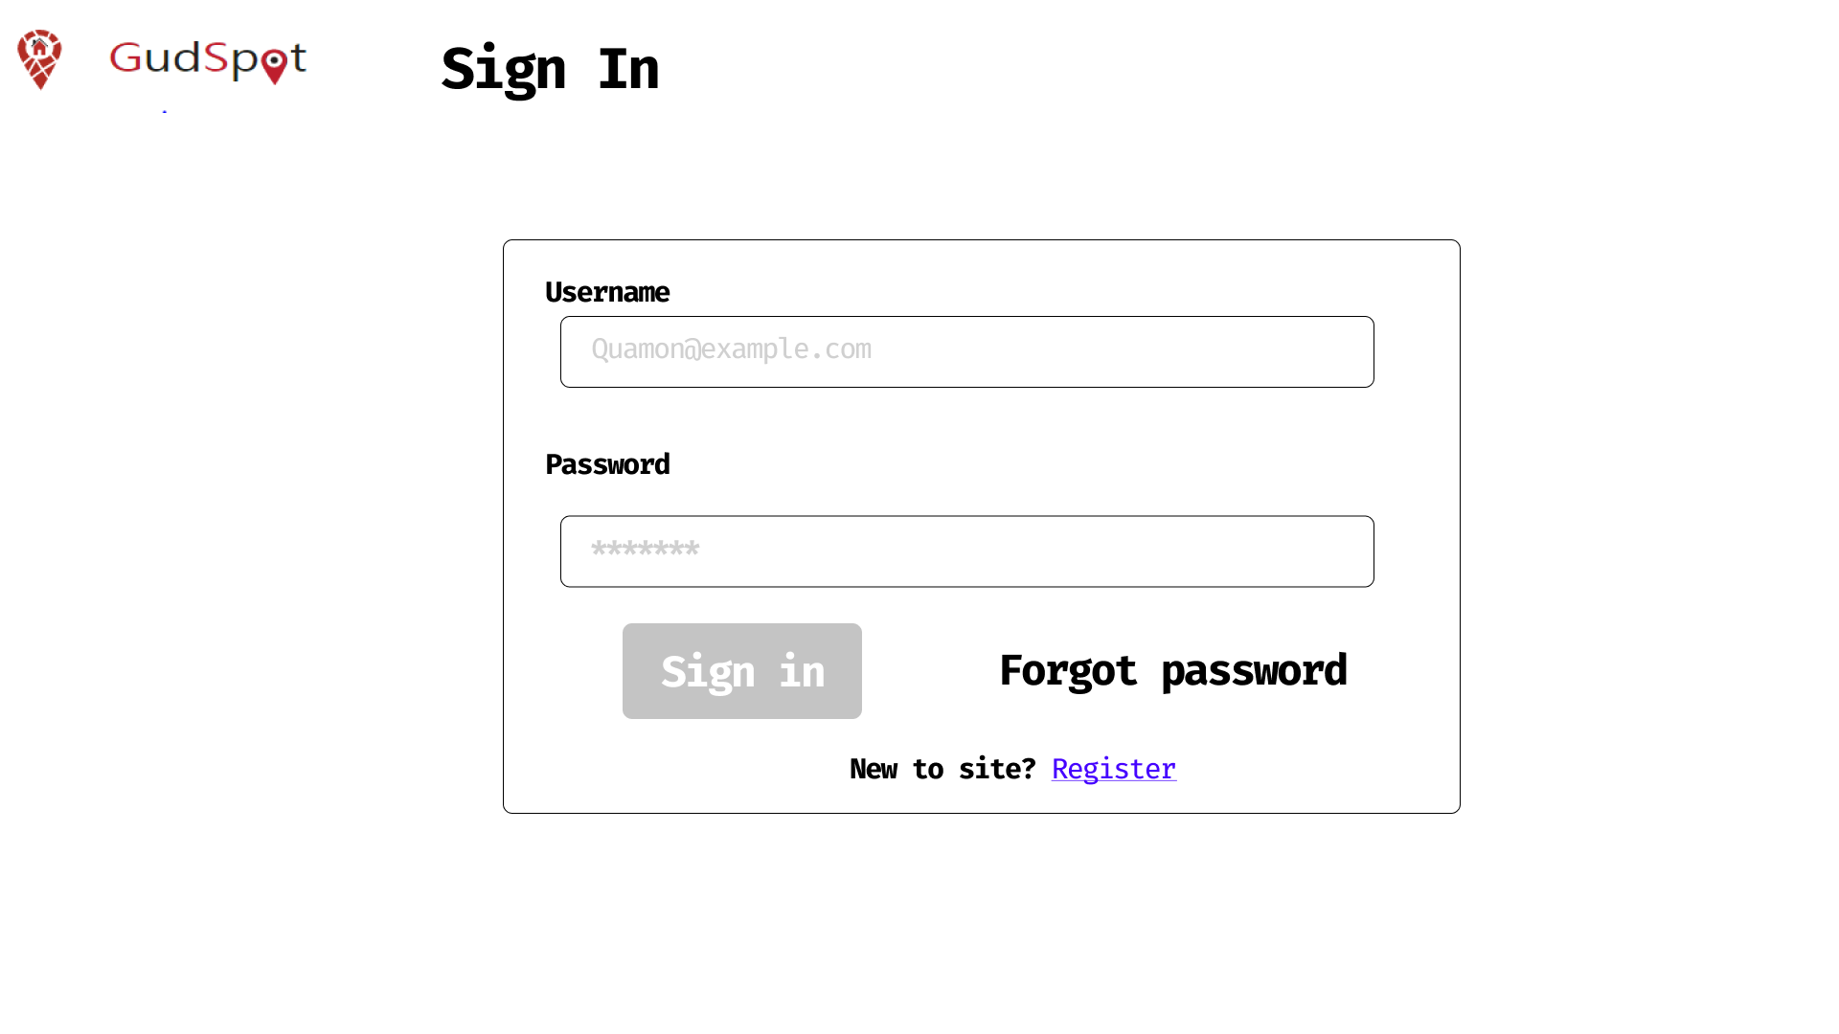

After registering successfully, the page moves automatically to sign in

**4/Sign in-out**

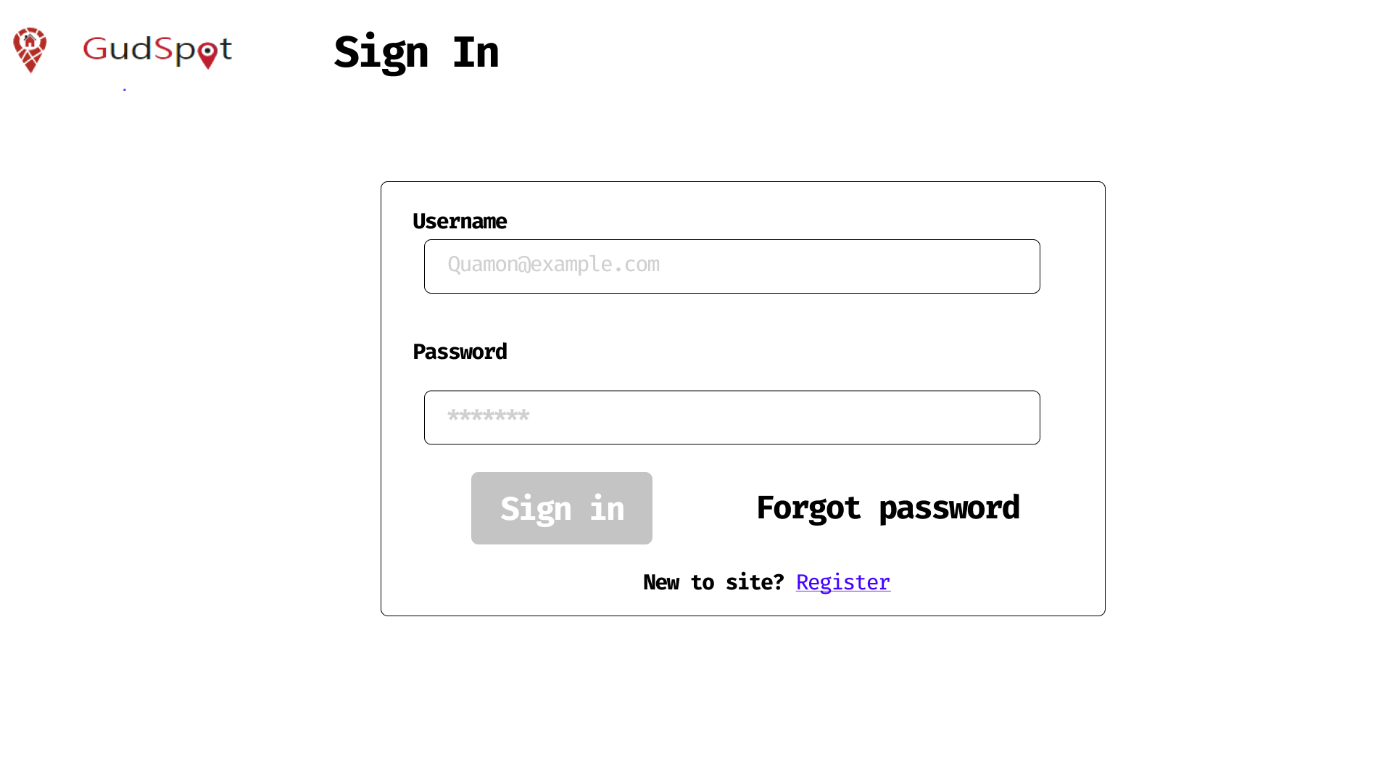After registering successfully or clicking the sign in button at homepage.

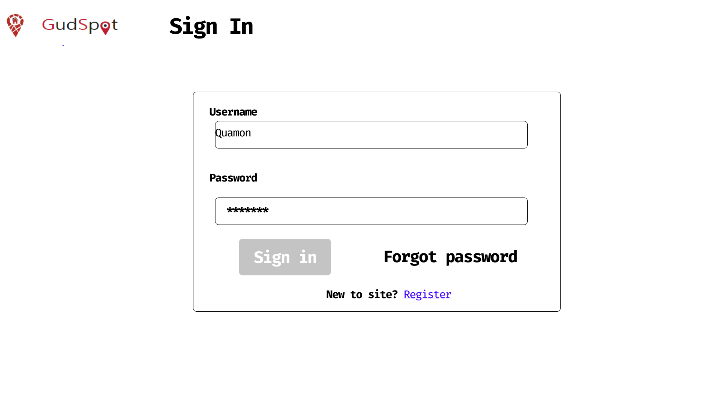

After input account information, click the sign in button.

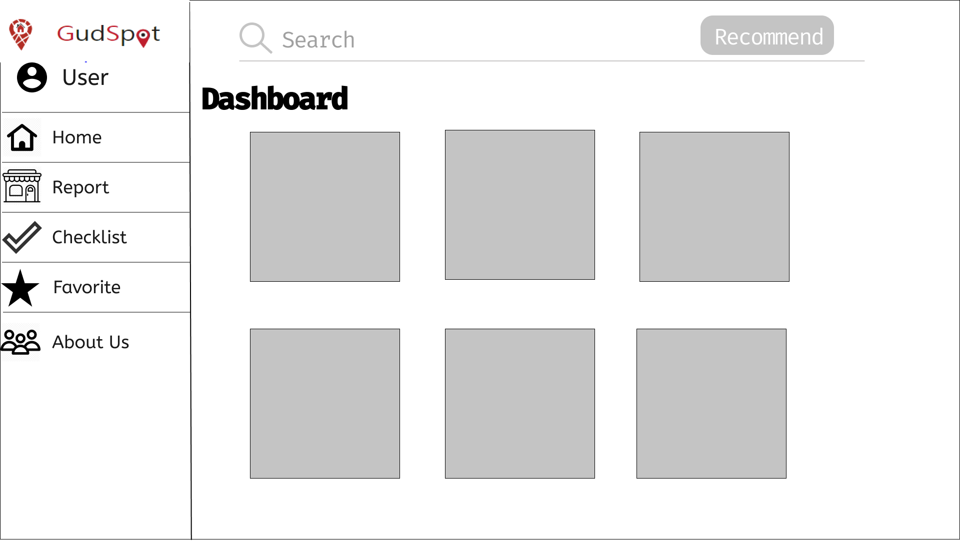

Sign in successfully.

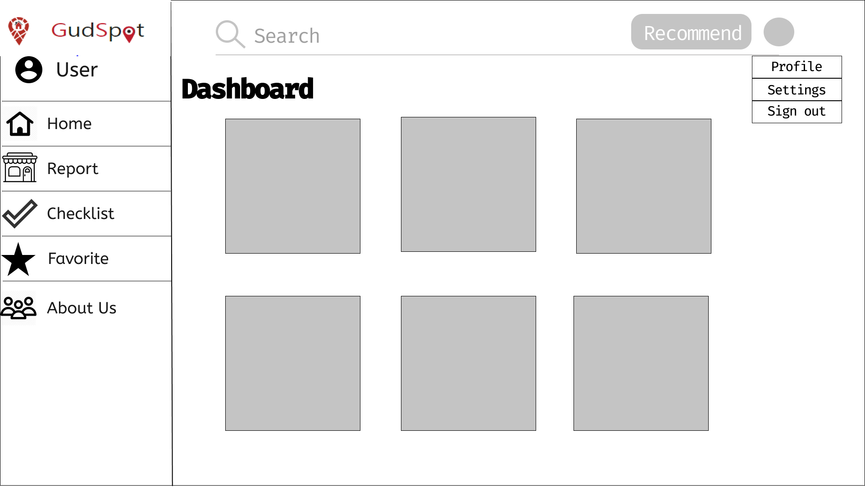

Click the avatar button to show a dropdown menu.

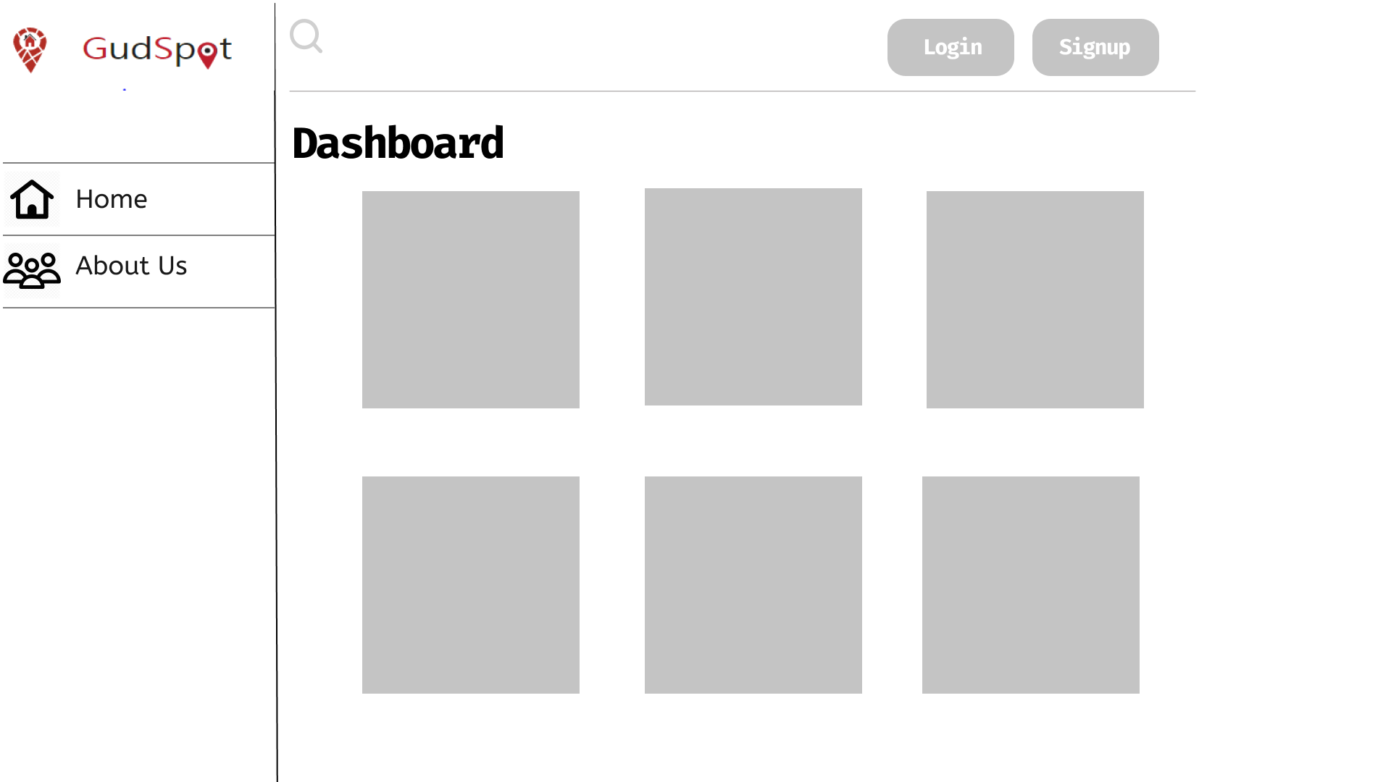

Choose the sign out button to sign out from the account.

**5/ Change account information**

The main screen of the change page, we can change the information of the user in this page

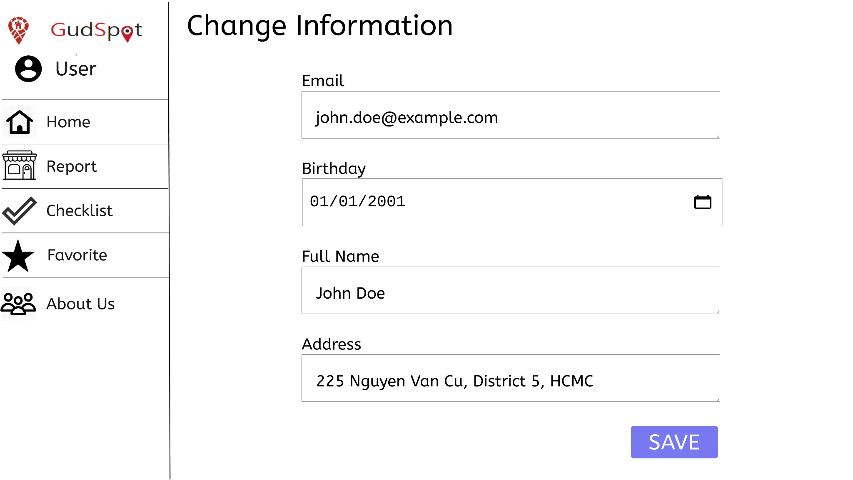

The next image describes the information after changing

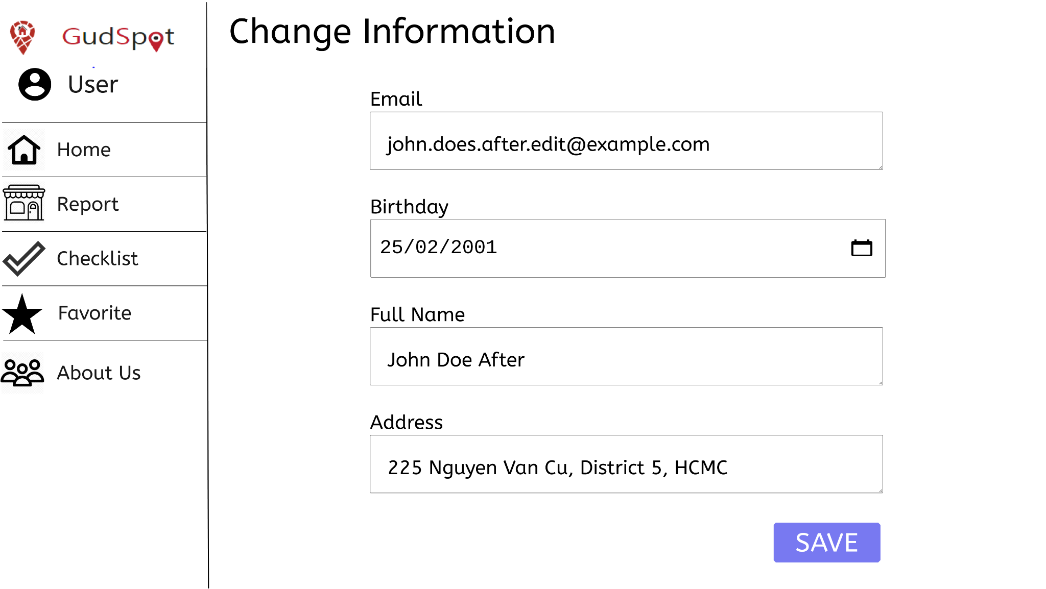

The last image describes the change page after clicking SAVE button

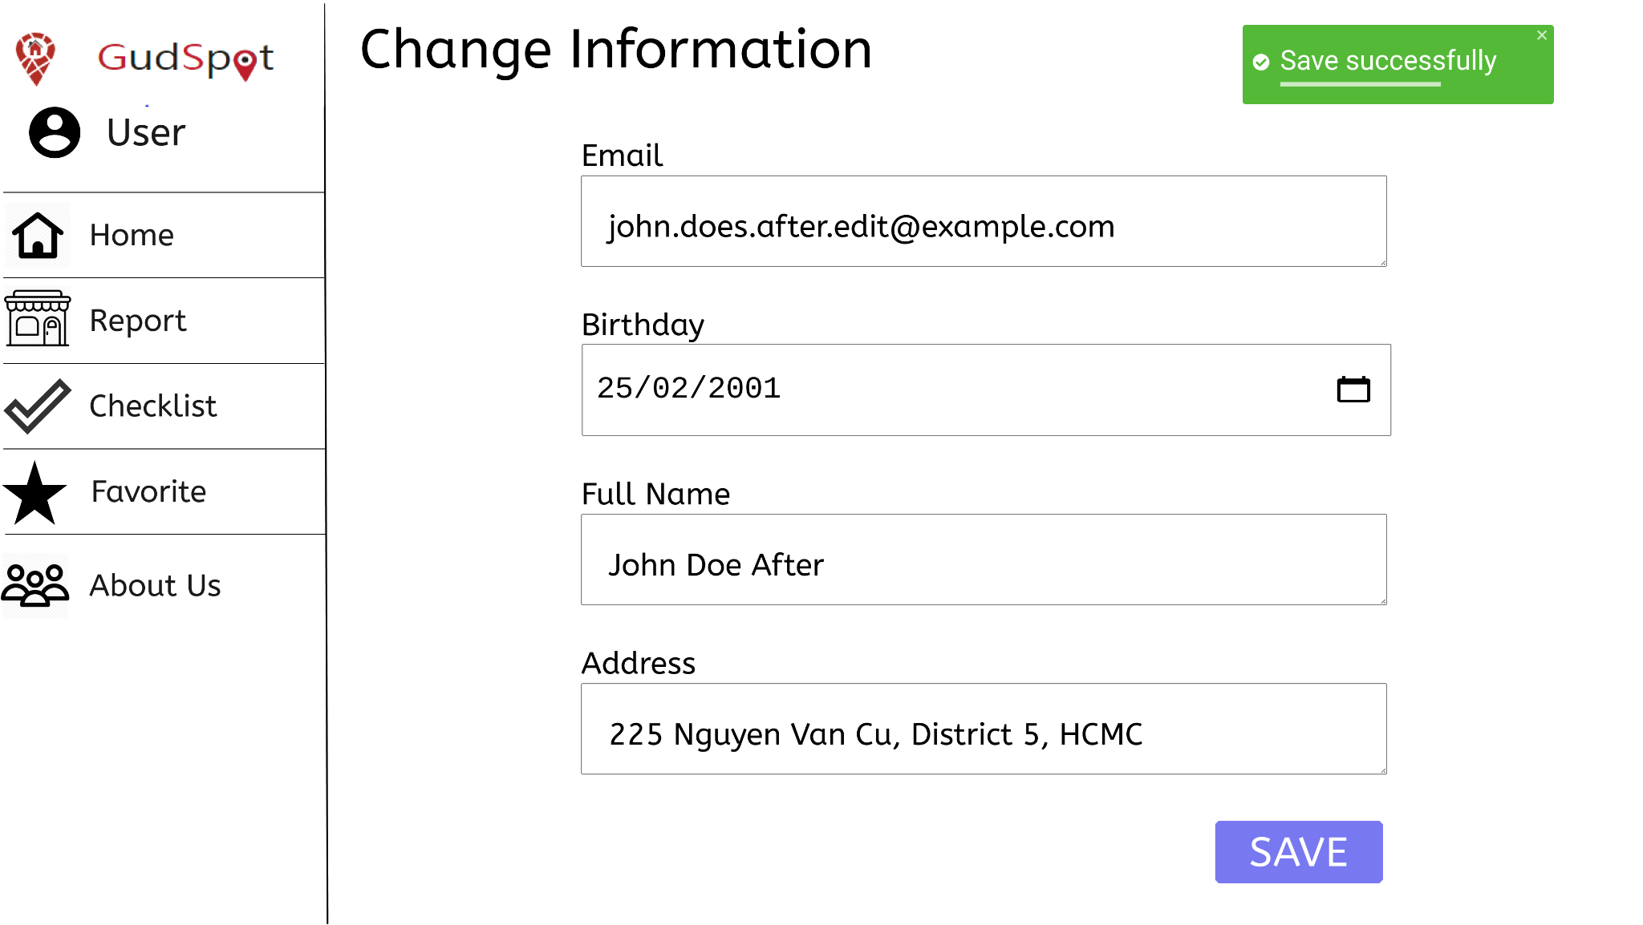

**6/ Like and follow page**

The store page when click into the store

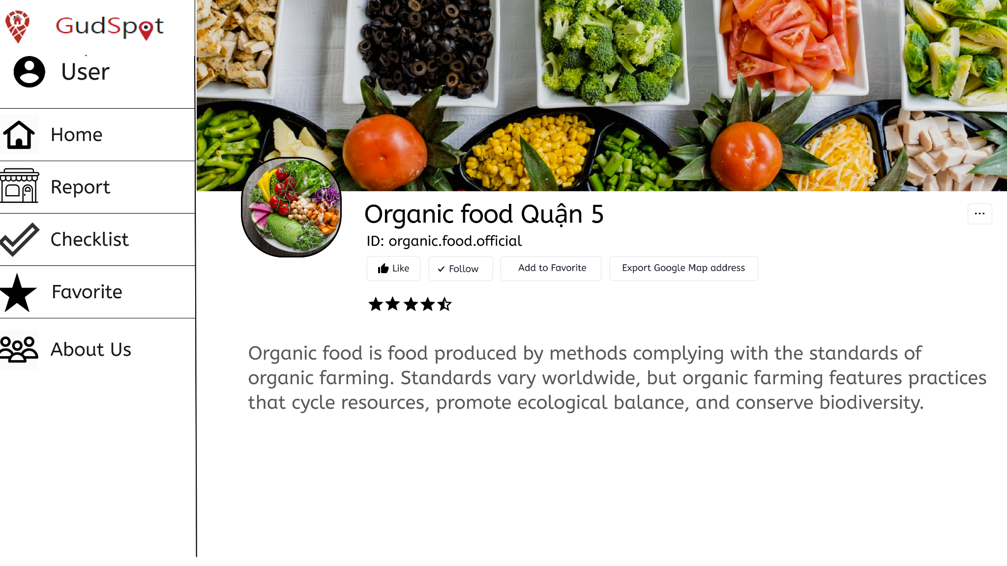

The next image describes the page after click Following

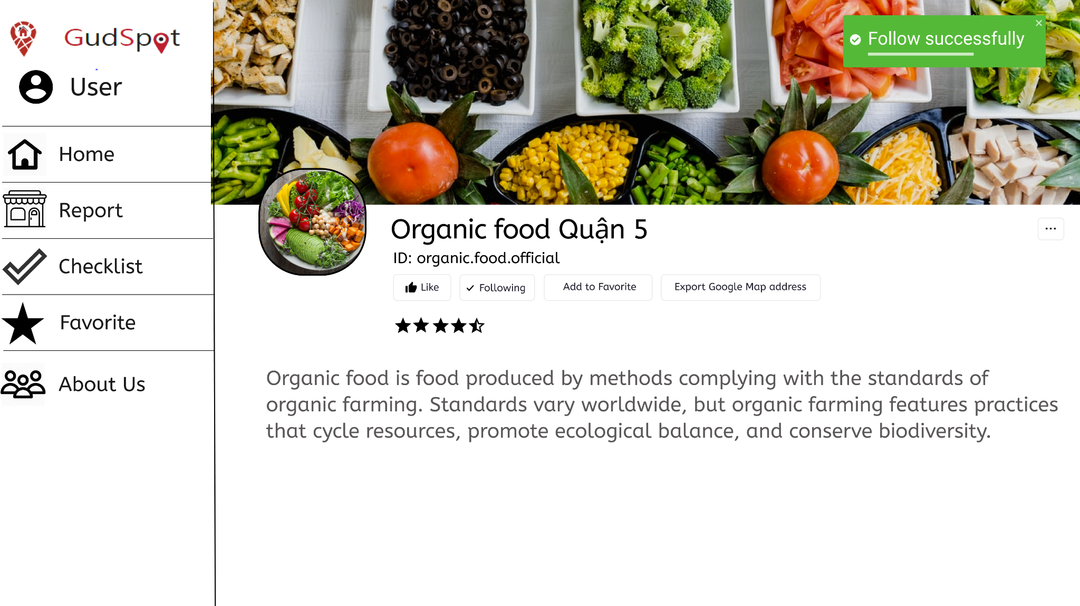

The last image describes the page after click Like

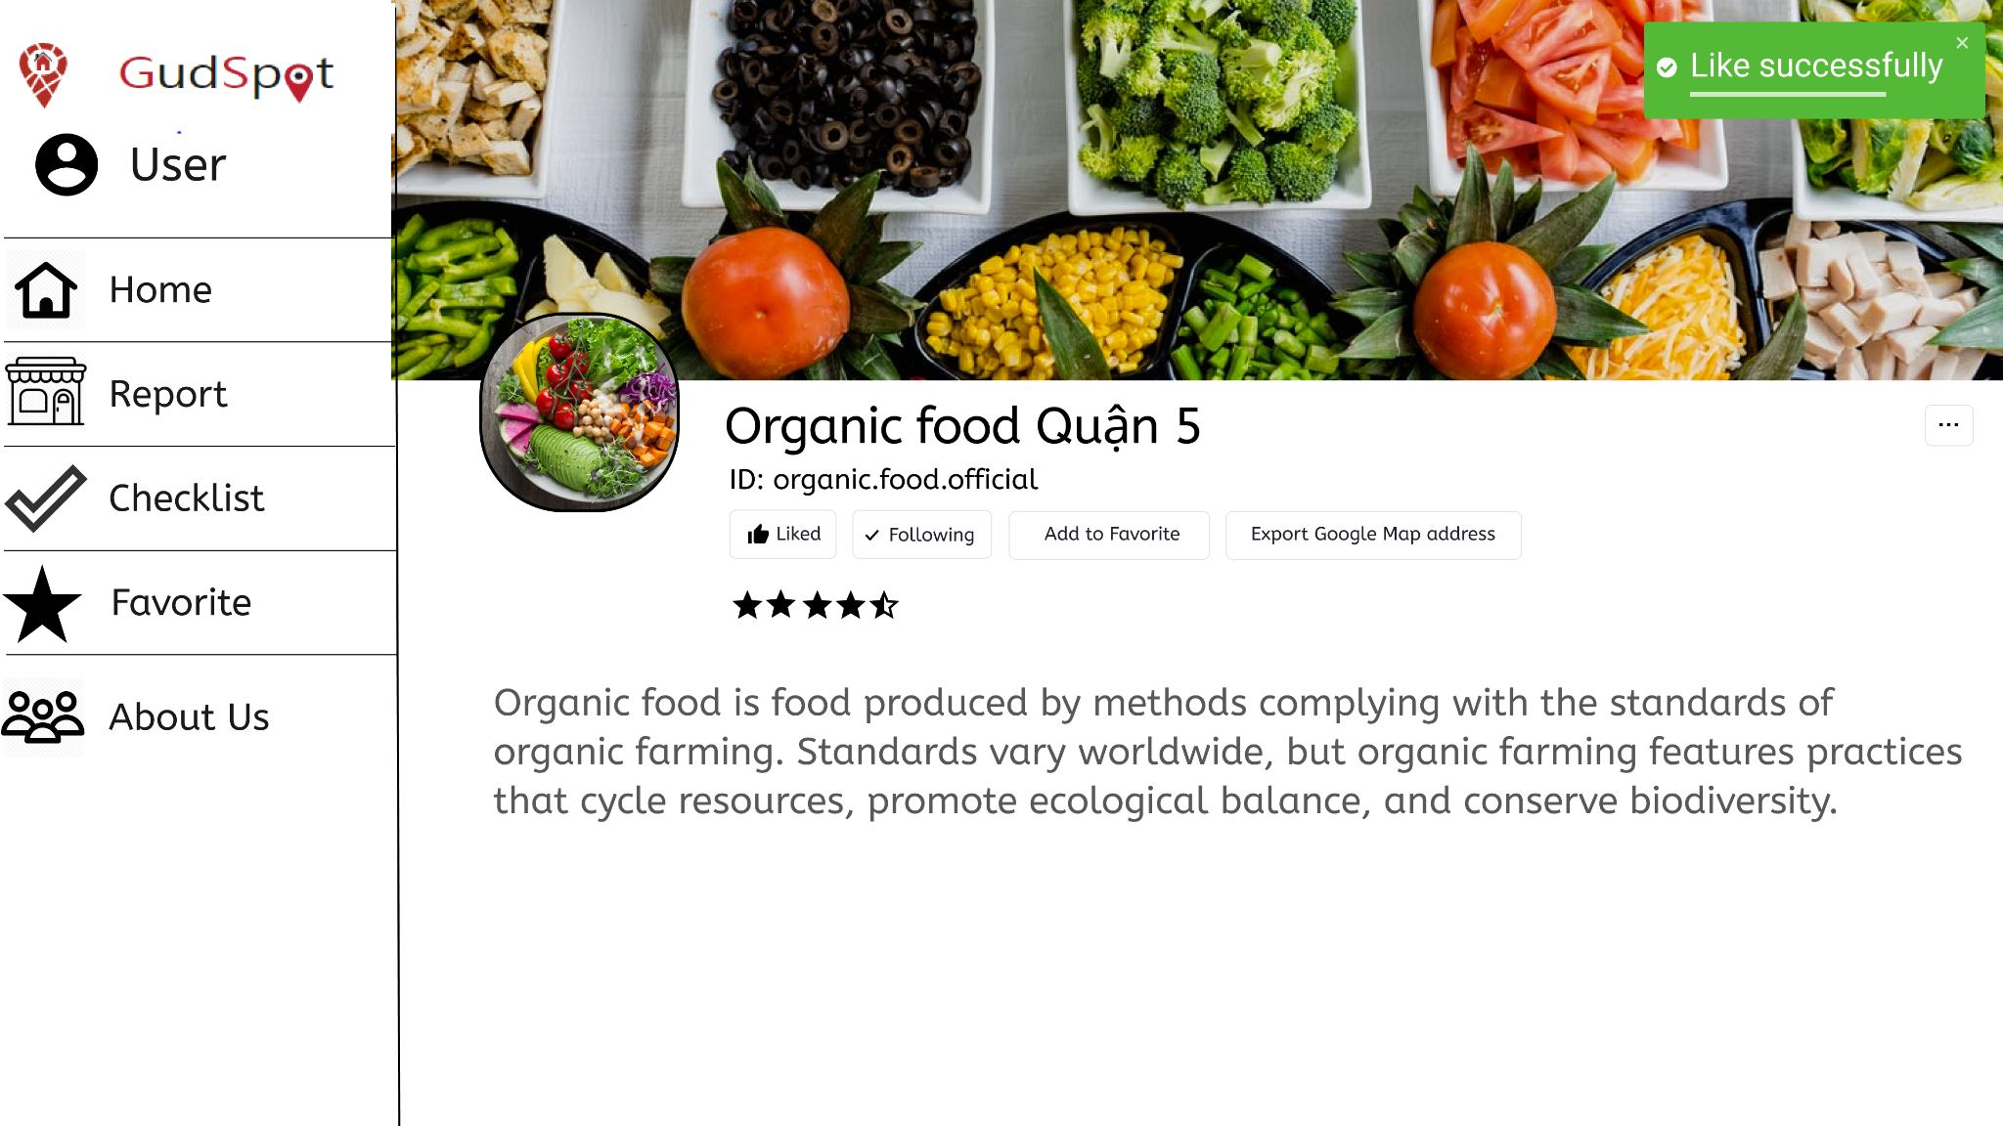

**7/ Comment on blog**

The comment component when click into the blog

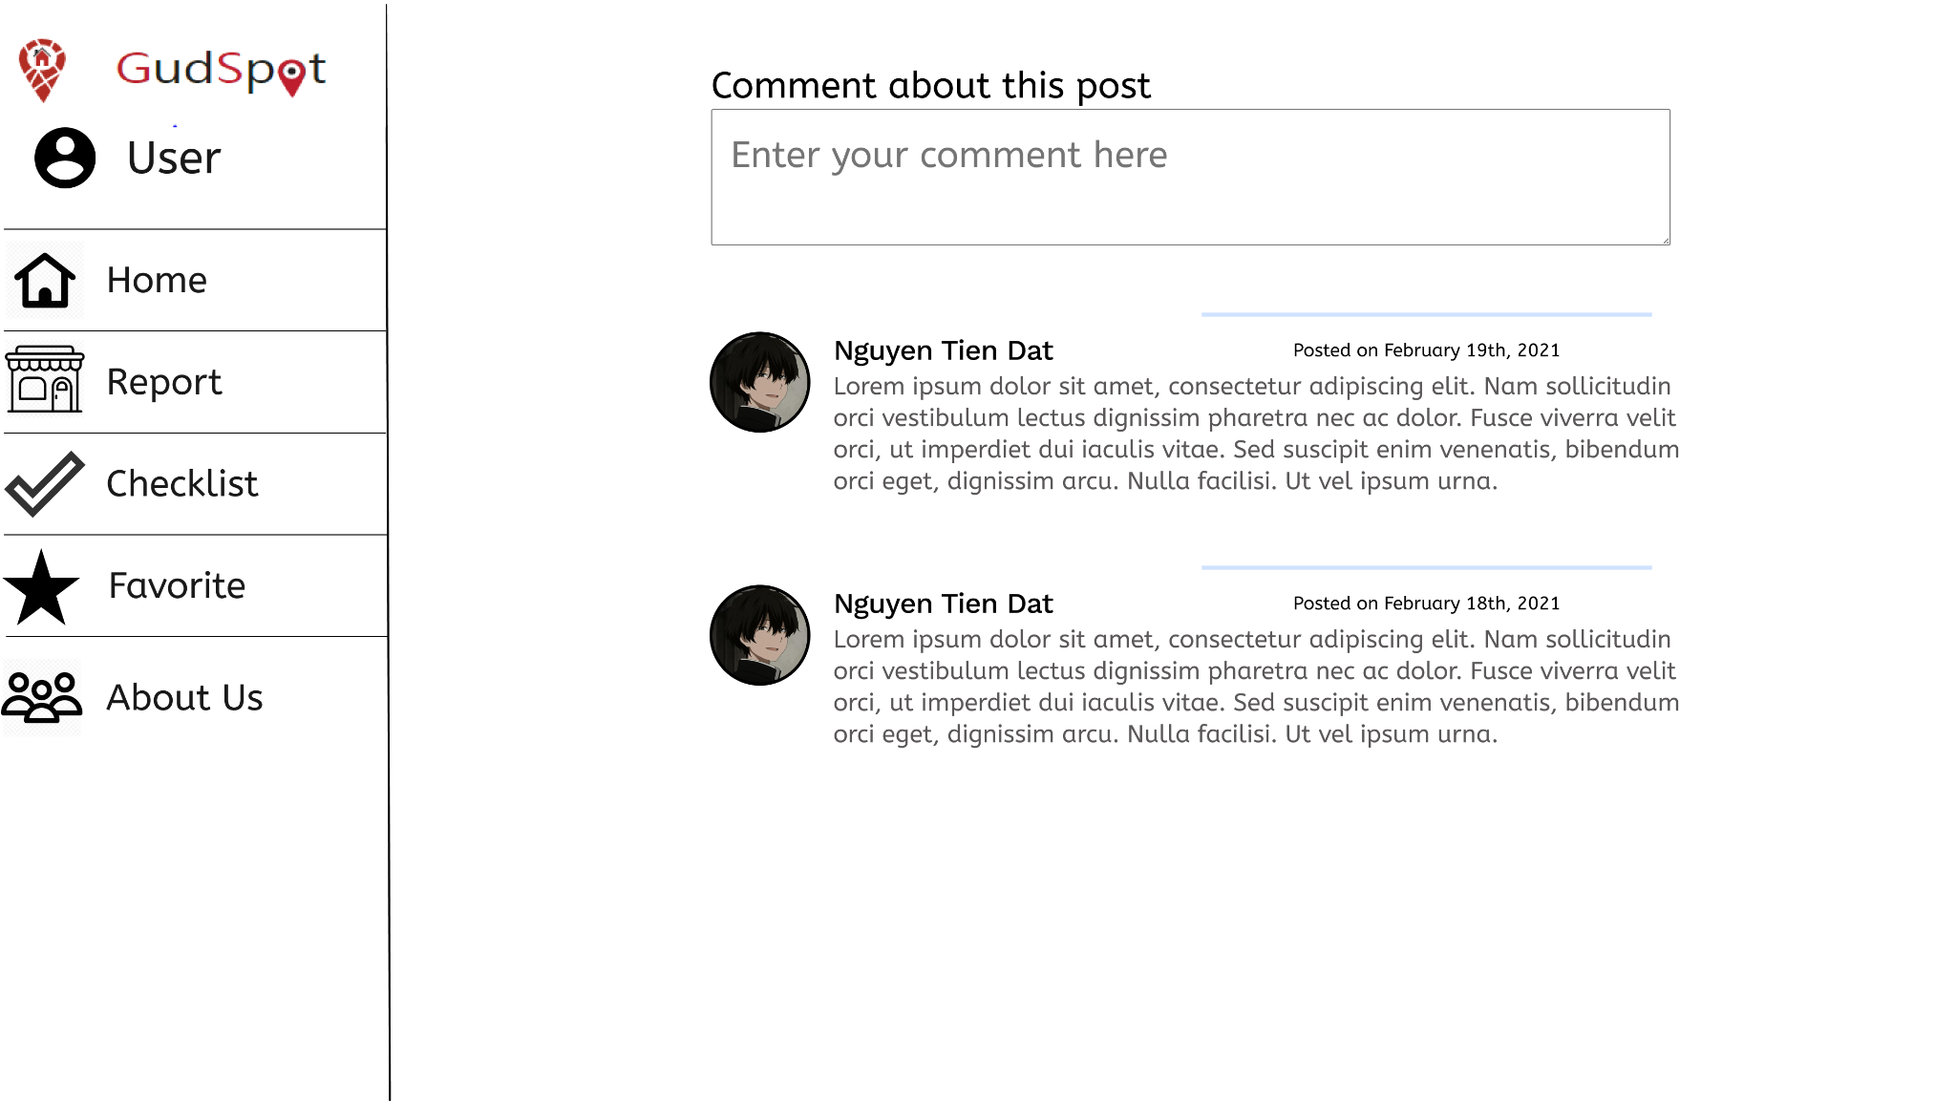

The next image describes the user typing the comment

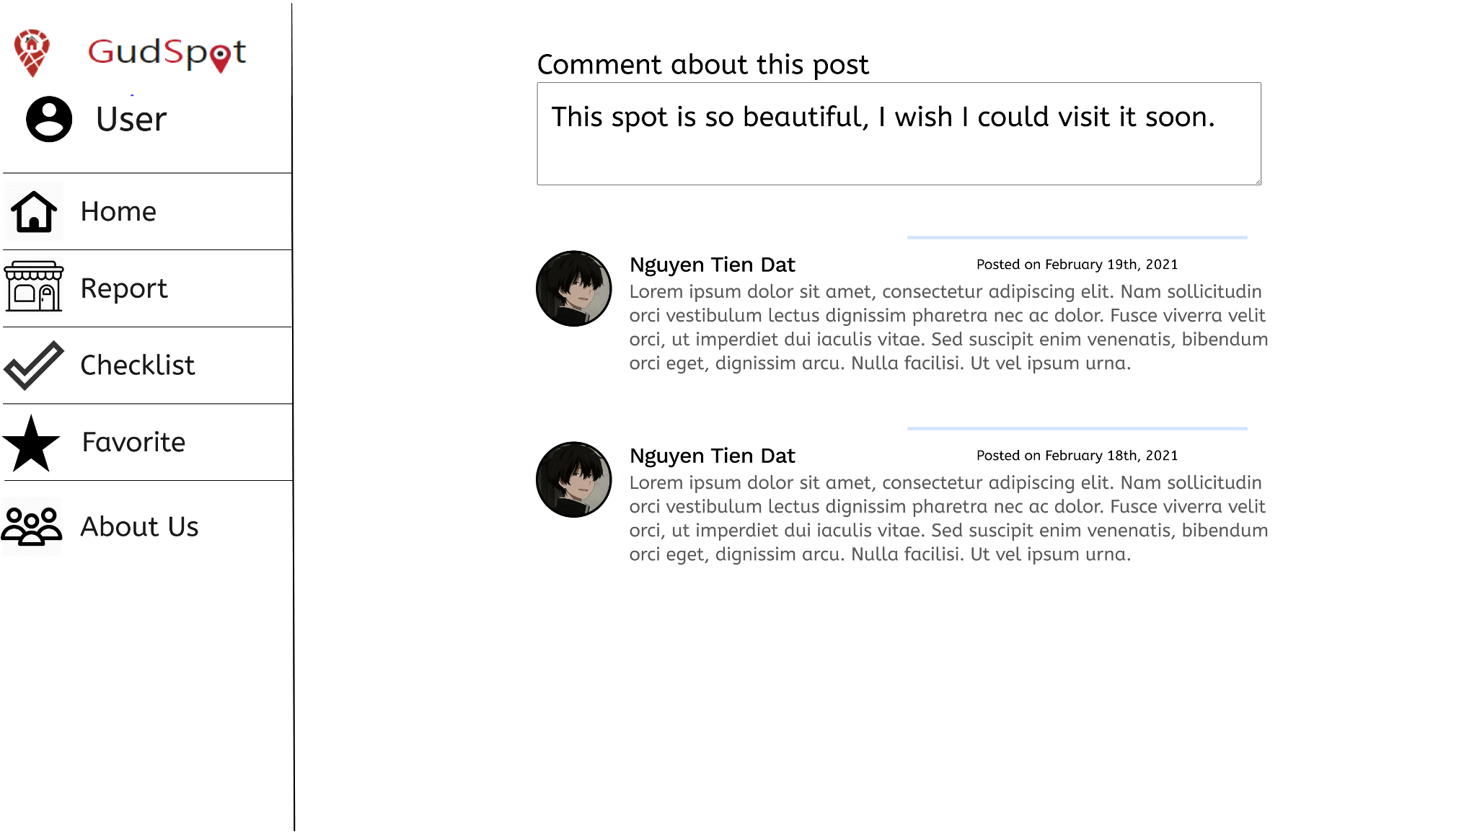

The last image describes the user submitting the comment successfully.

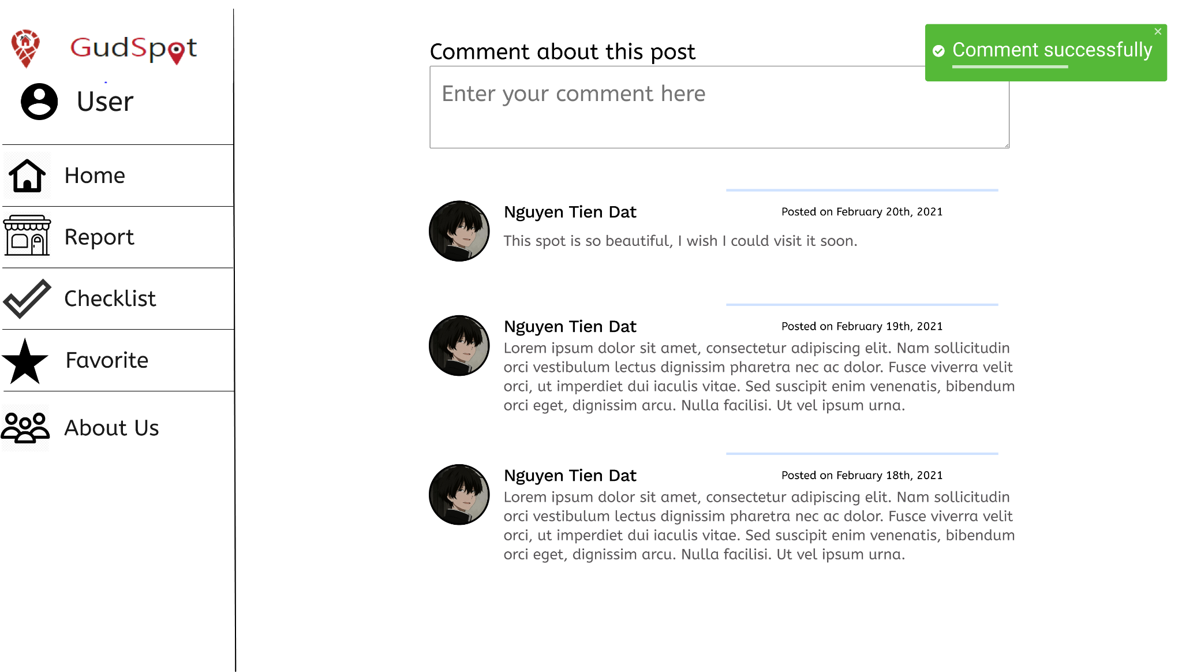

**8/ Create Favorite list**

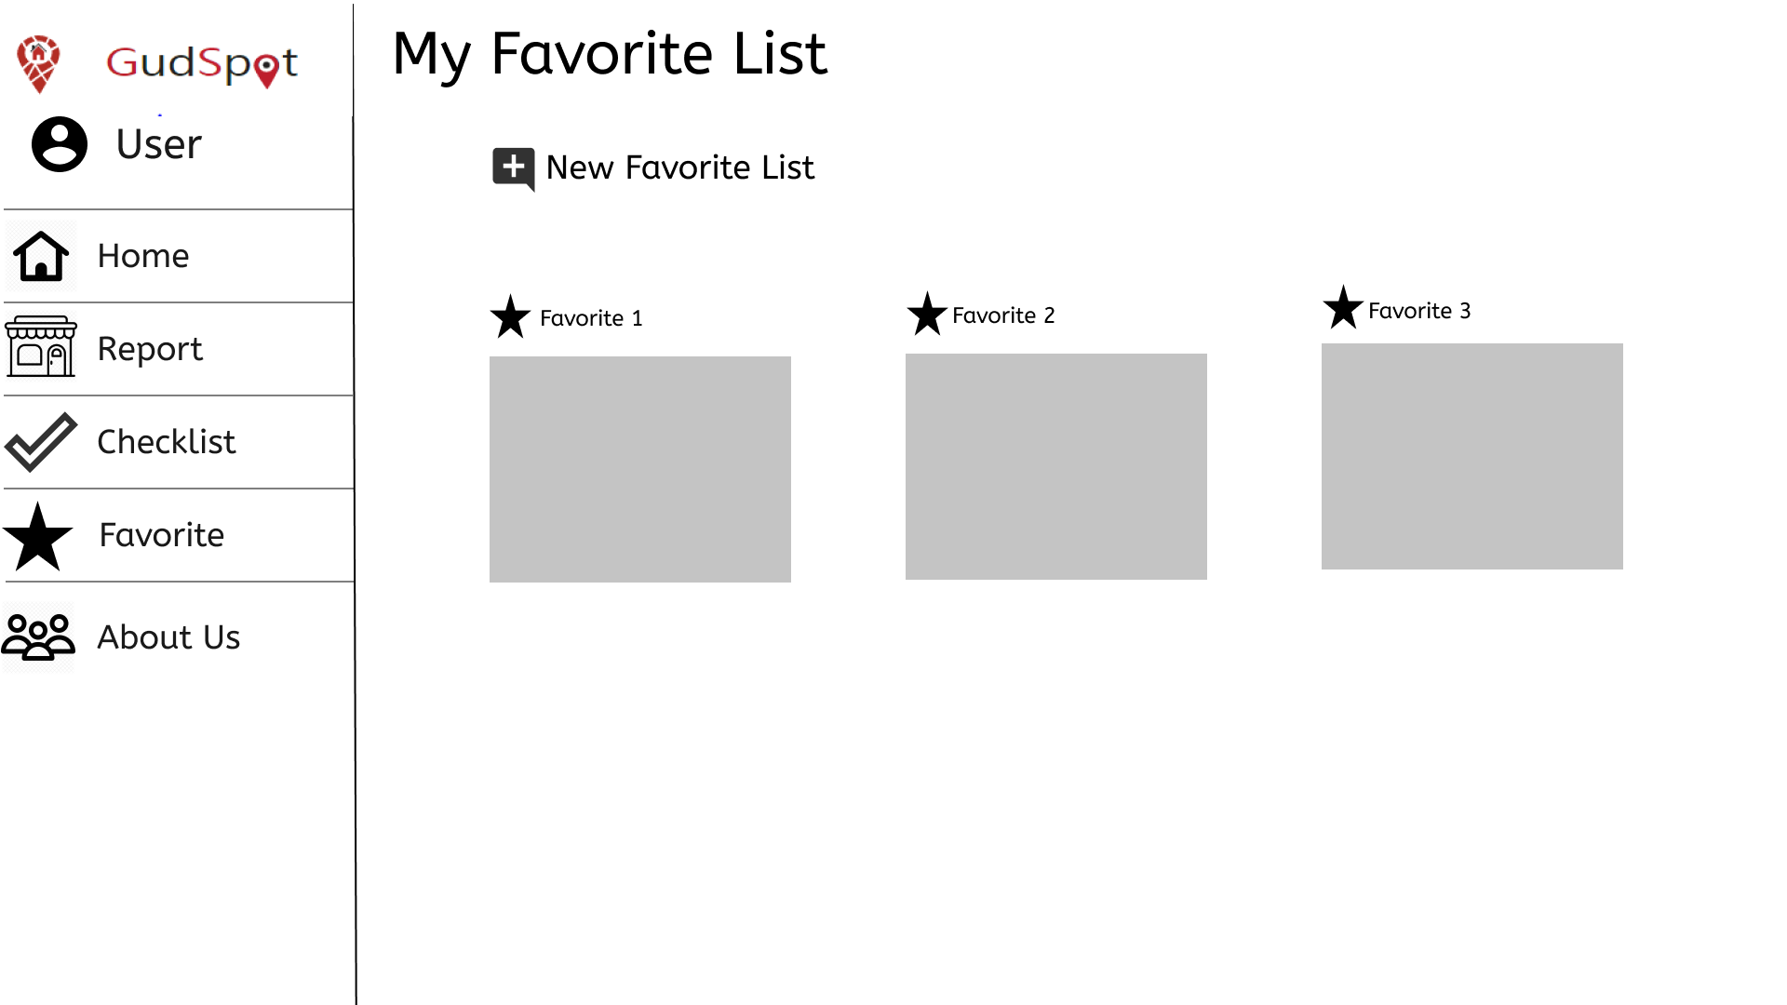

The main page of Favorite list will show all the Favorite list you have created. If there is no list, you can create one.

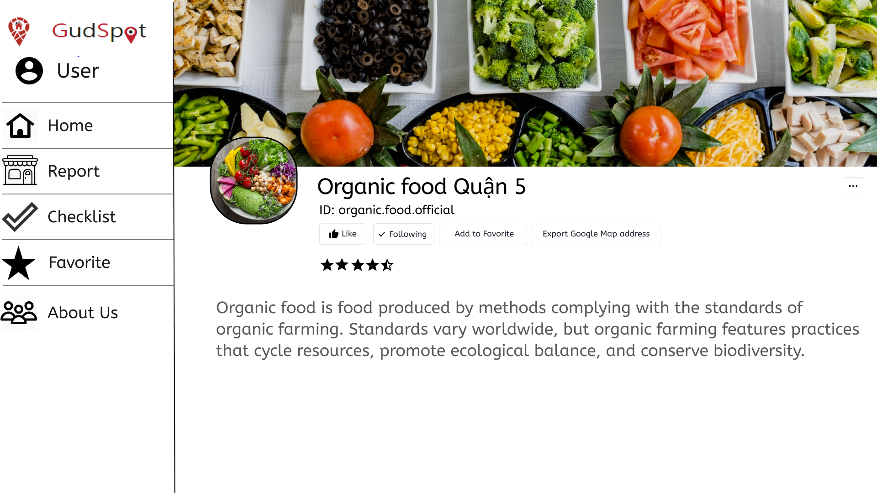

To add a place to your Favorite list, you can get to that place page and click on the Add to Favorite button. Then, that place will be stored into your Favorite list

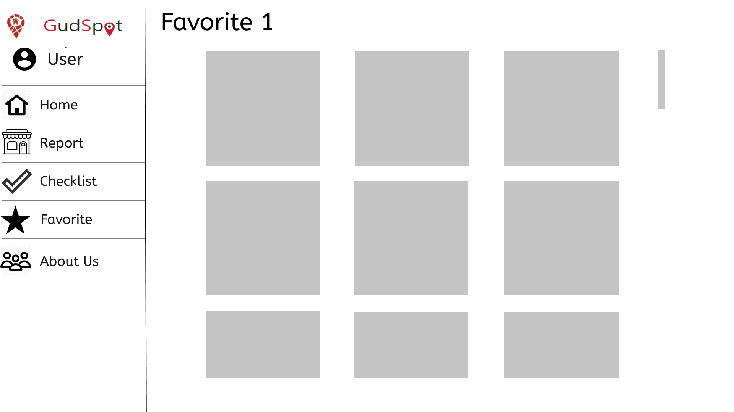

When you choose your favorite list, you will see a list of places that you have added to that list before.

**9/ Create Checklist**

Main checklist section , show all created checklist

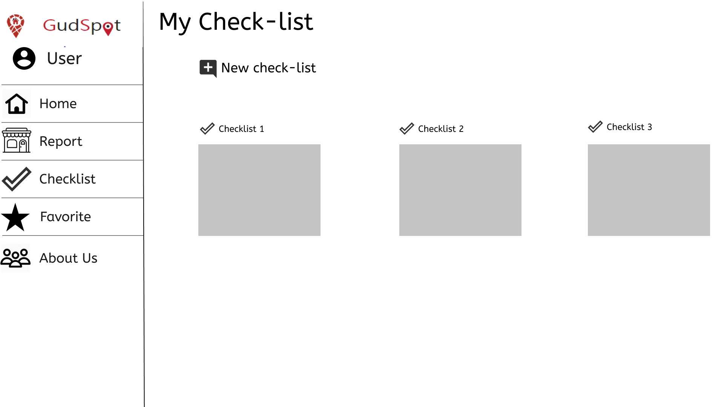

Create checklist view, showed when click “New checklist", more than one content has been added, then create button will be available

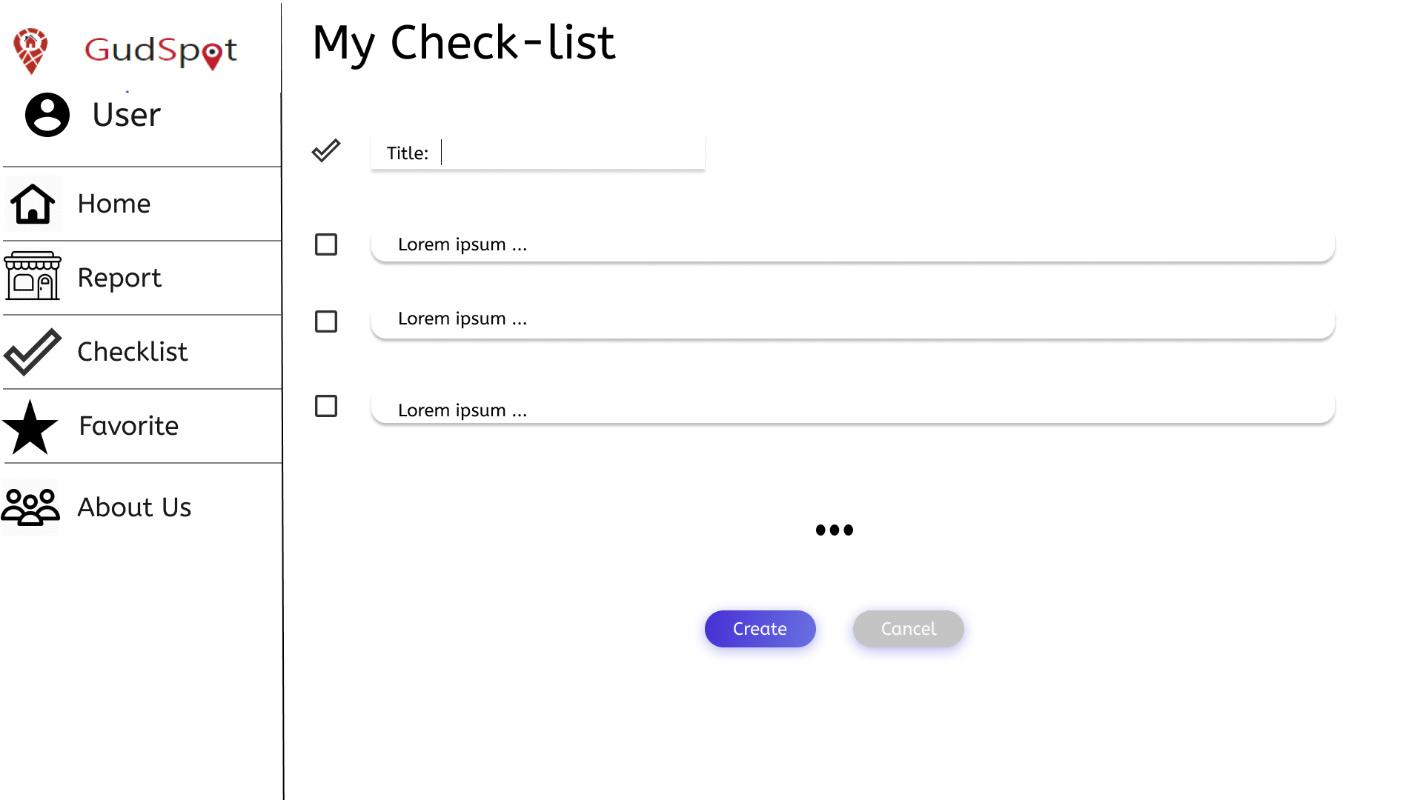

Checklist create, if nothing is added, create will not be available

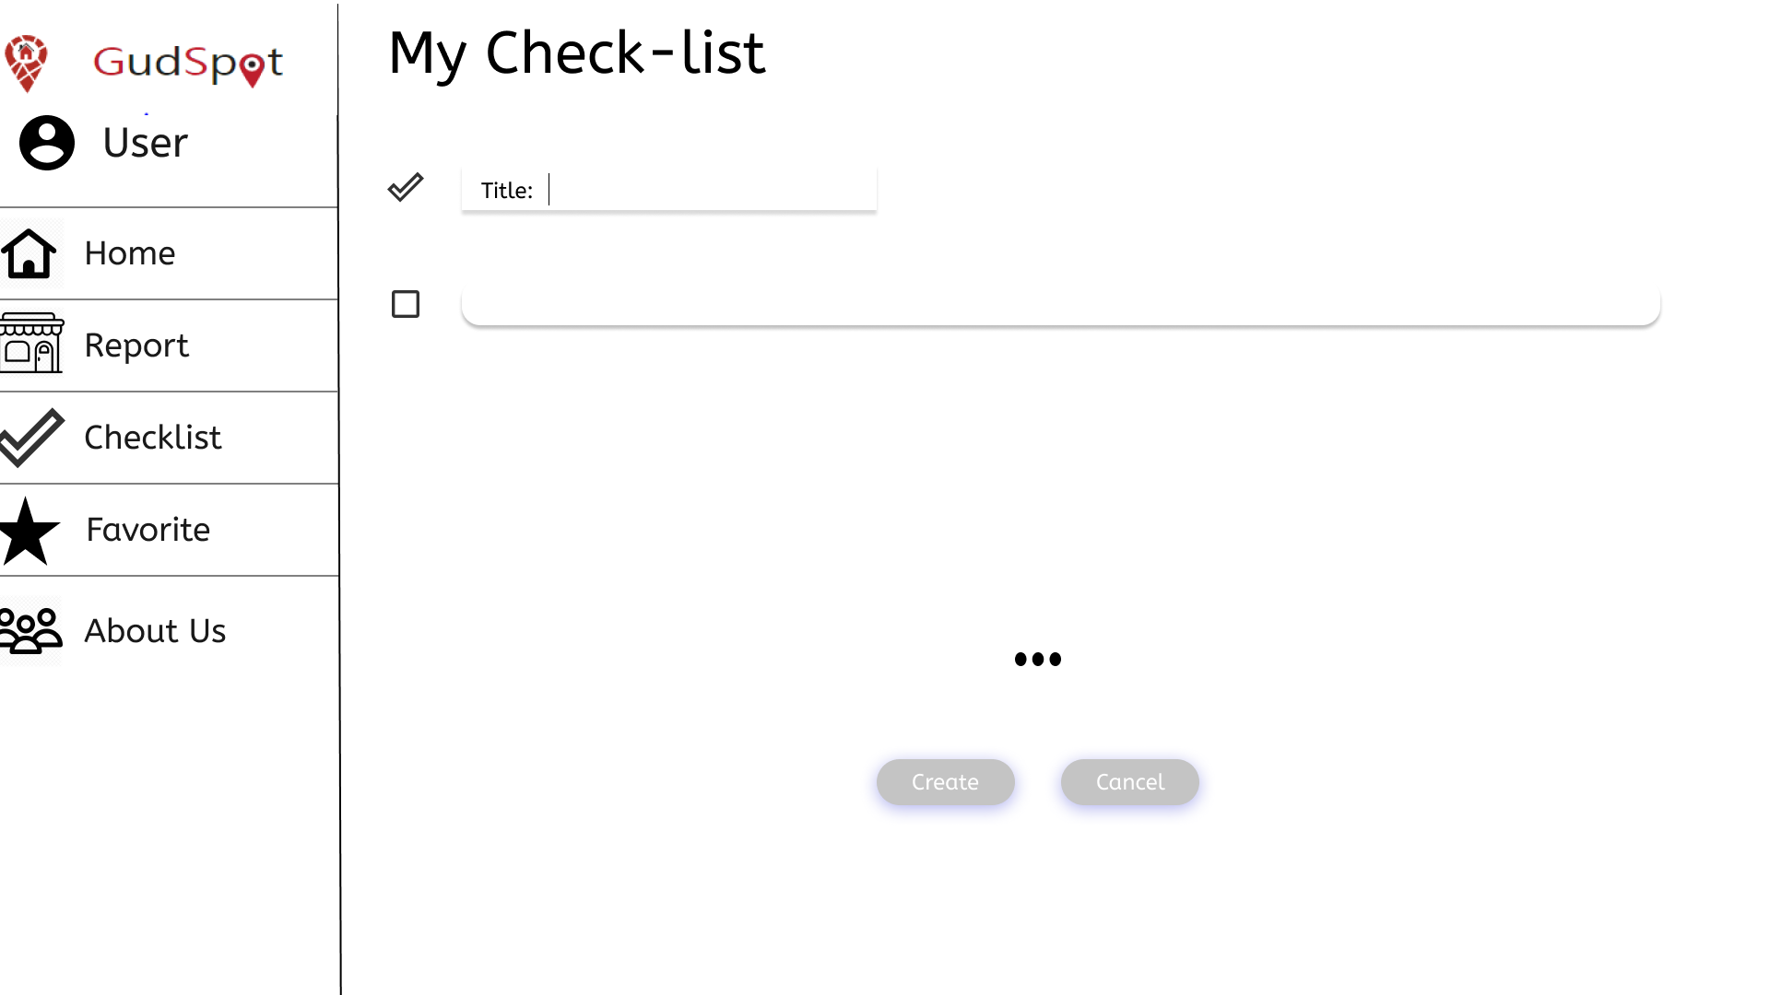

**10/ Write Blog**

Blog section, shows all user's created blogs

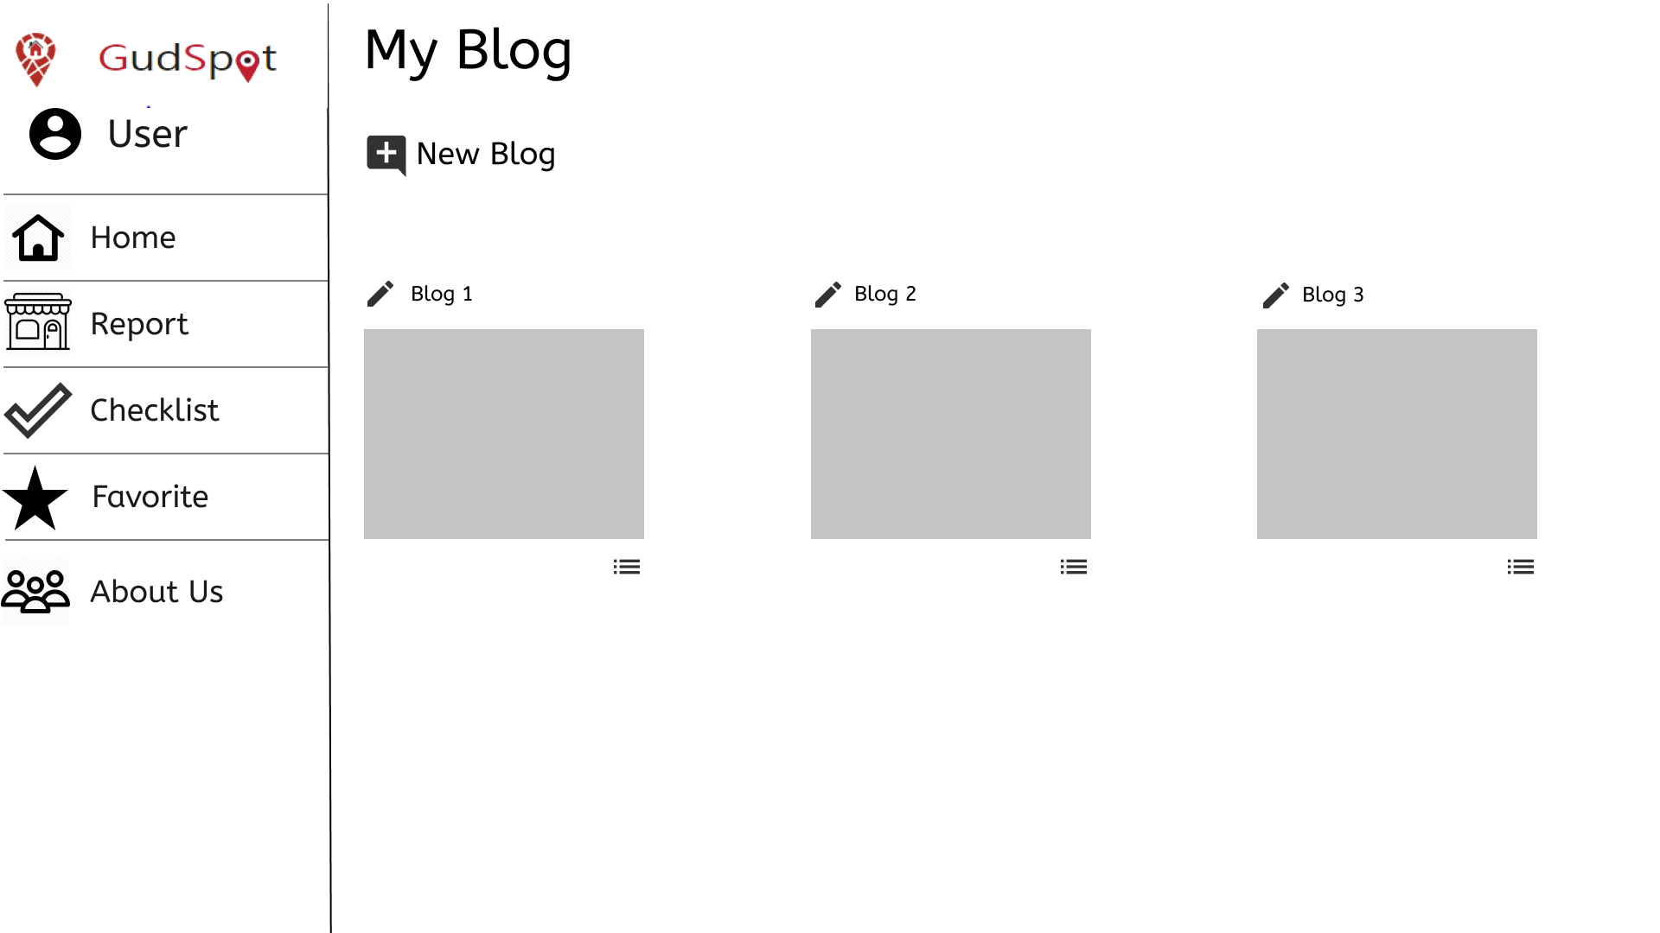

Blog section with no blog created

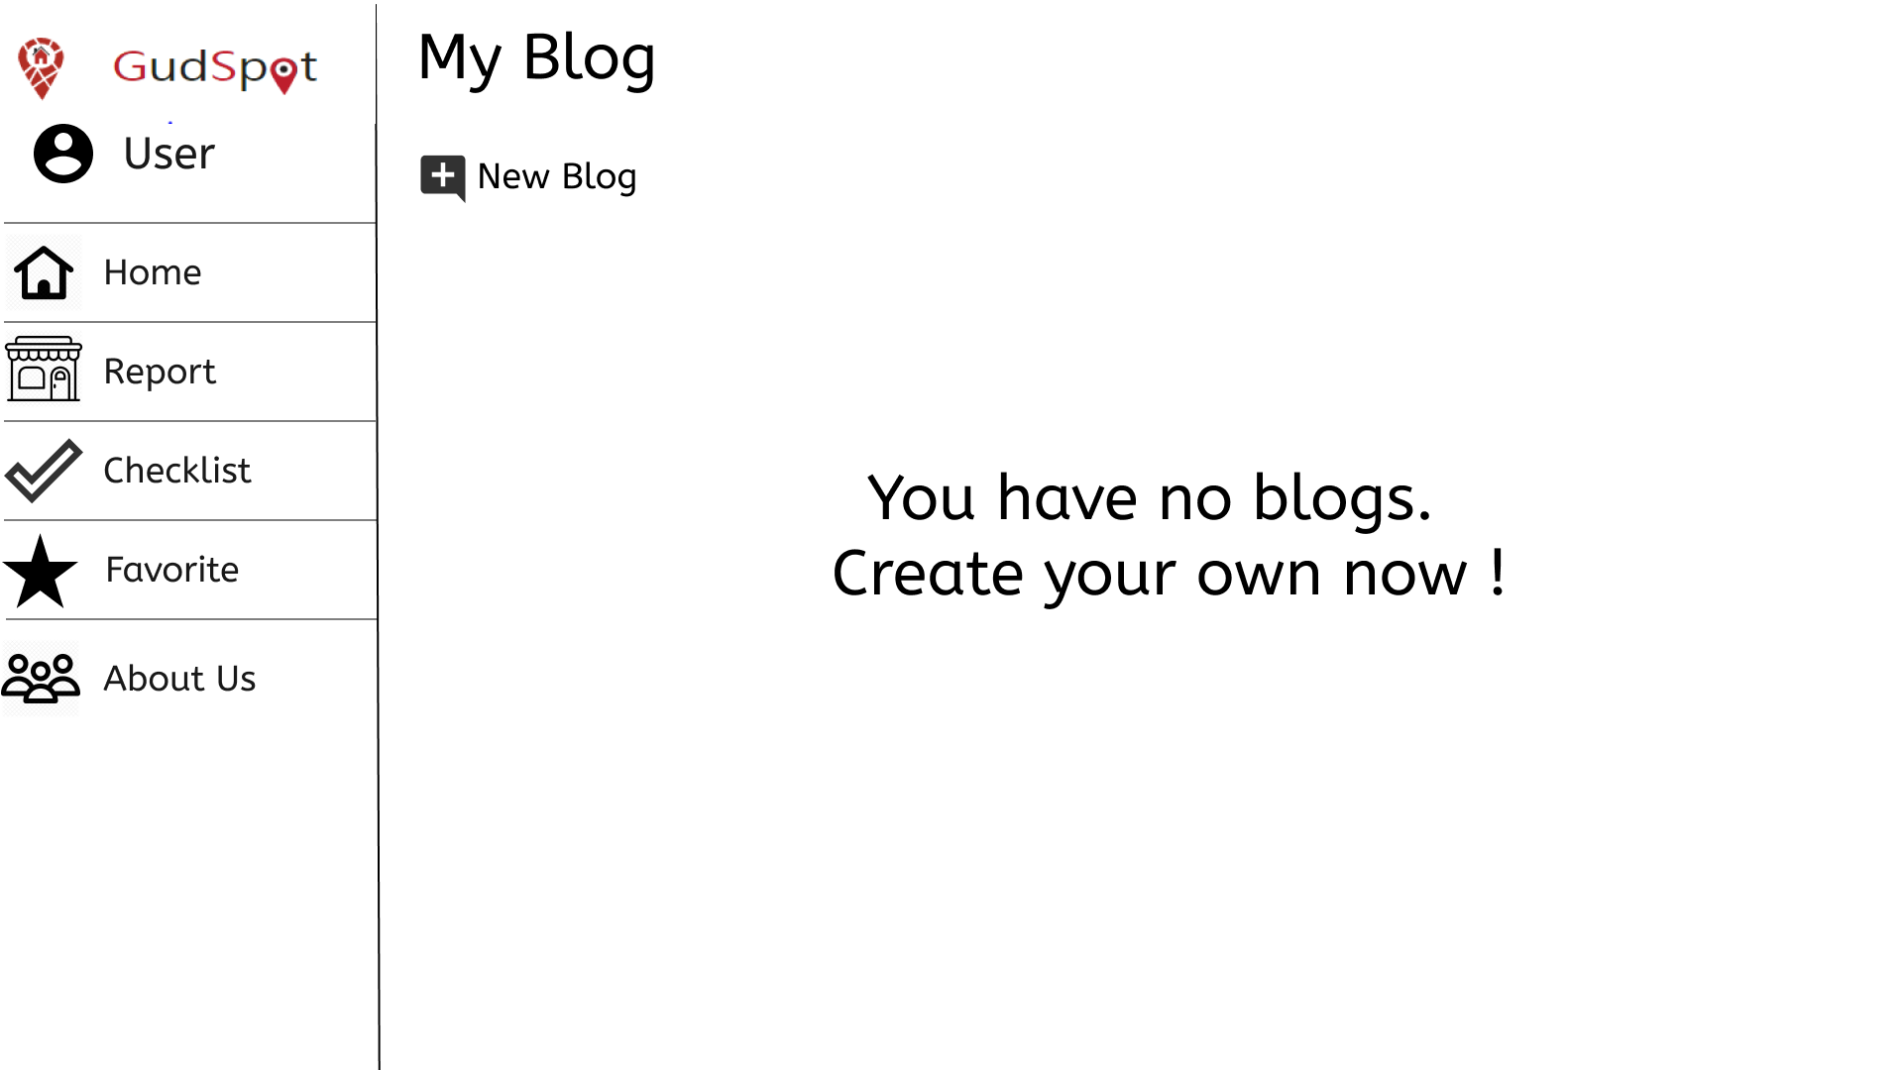

Create blog , showed when click New Blog.

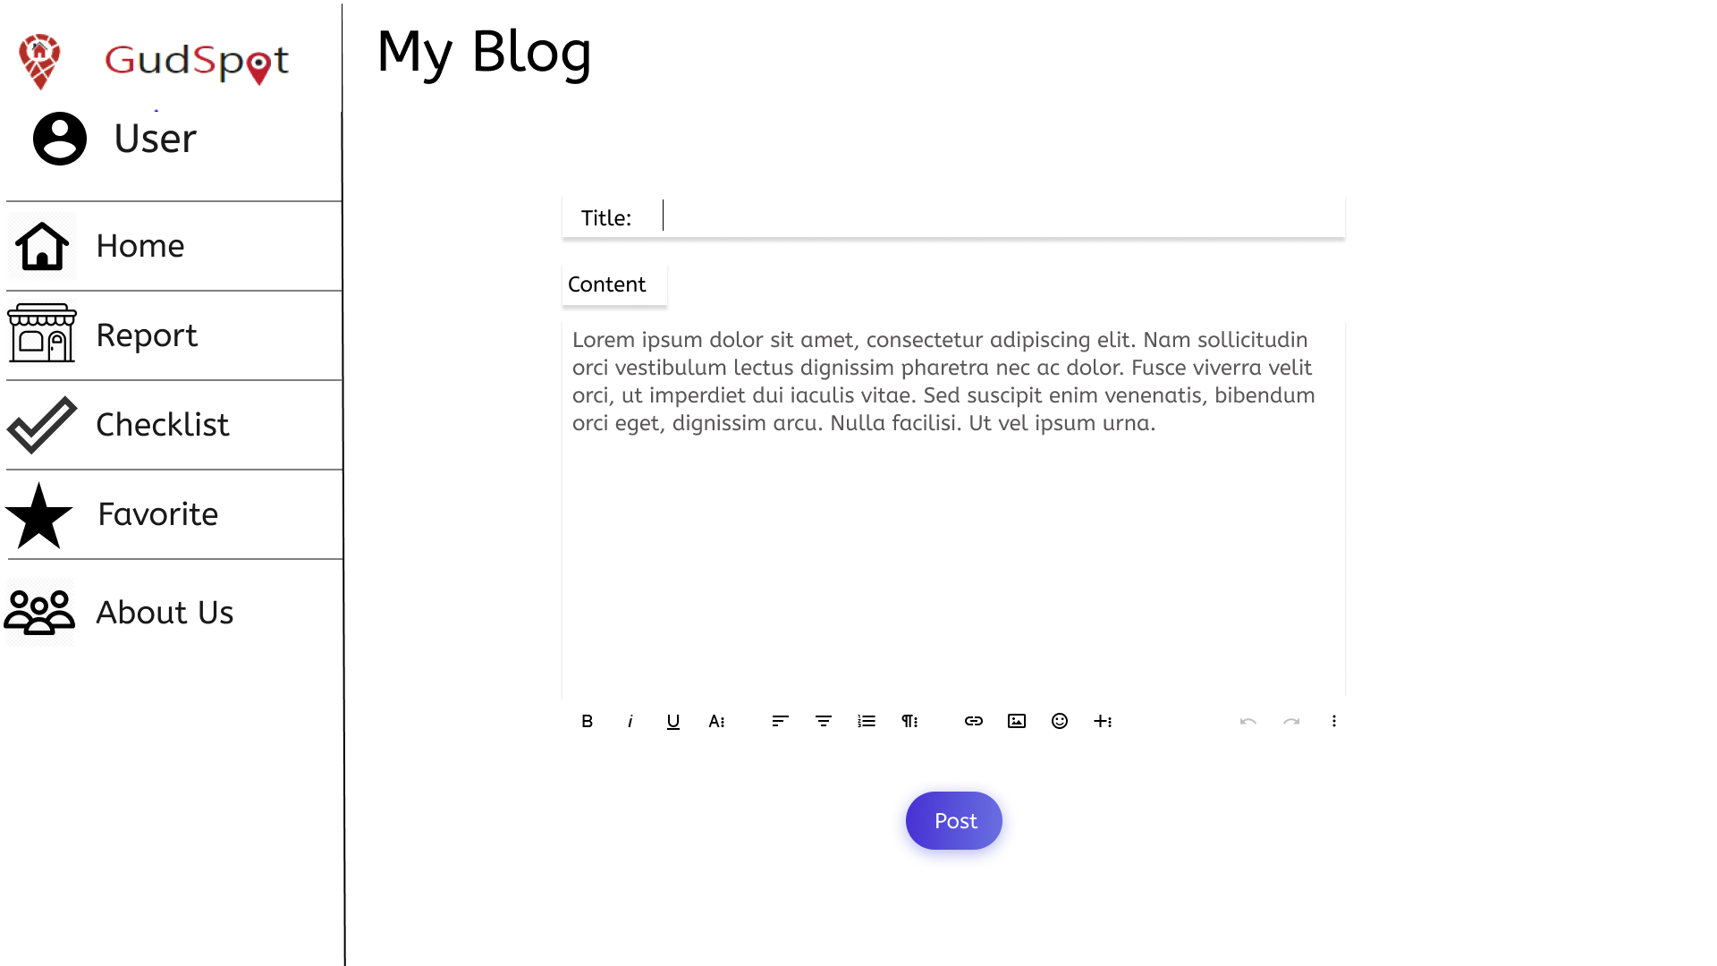

**11/ Post Image**

Integrated in blog create. Click on img icon to show.

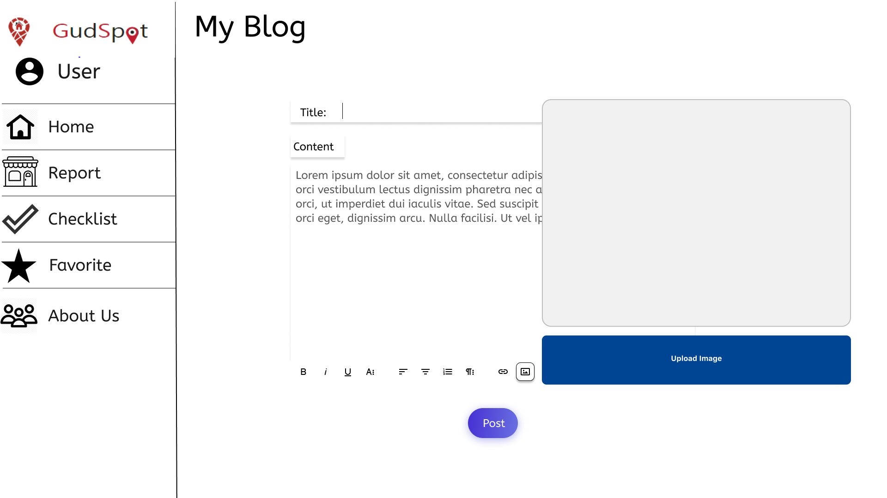

Drag image to choose

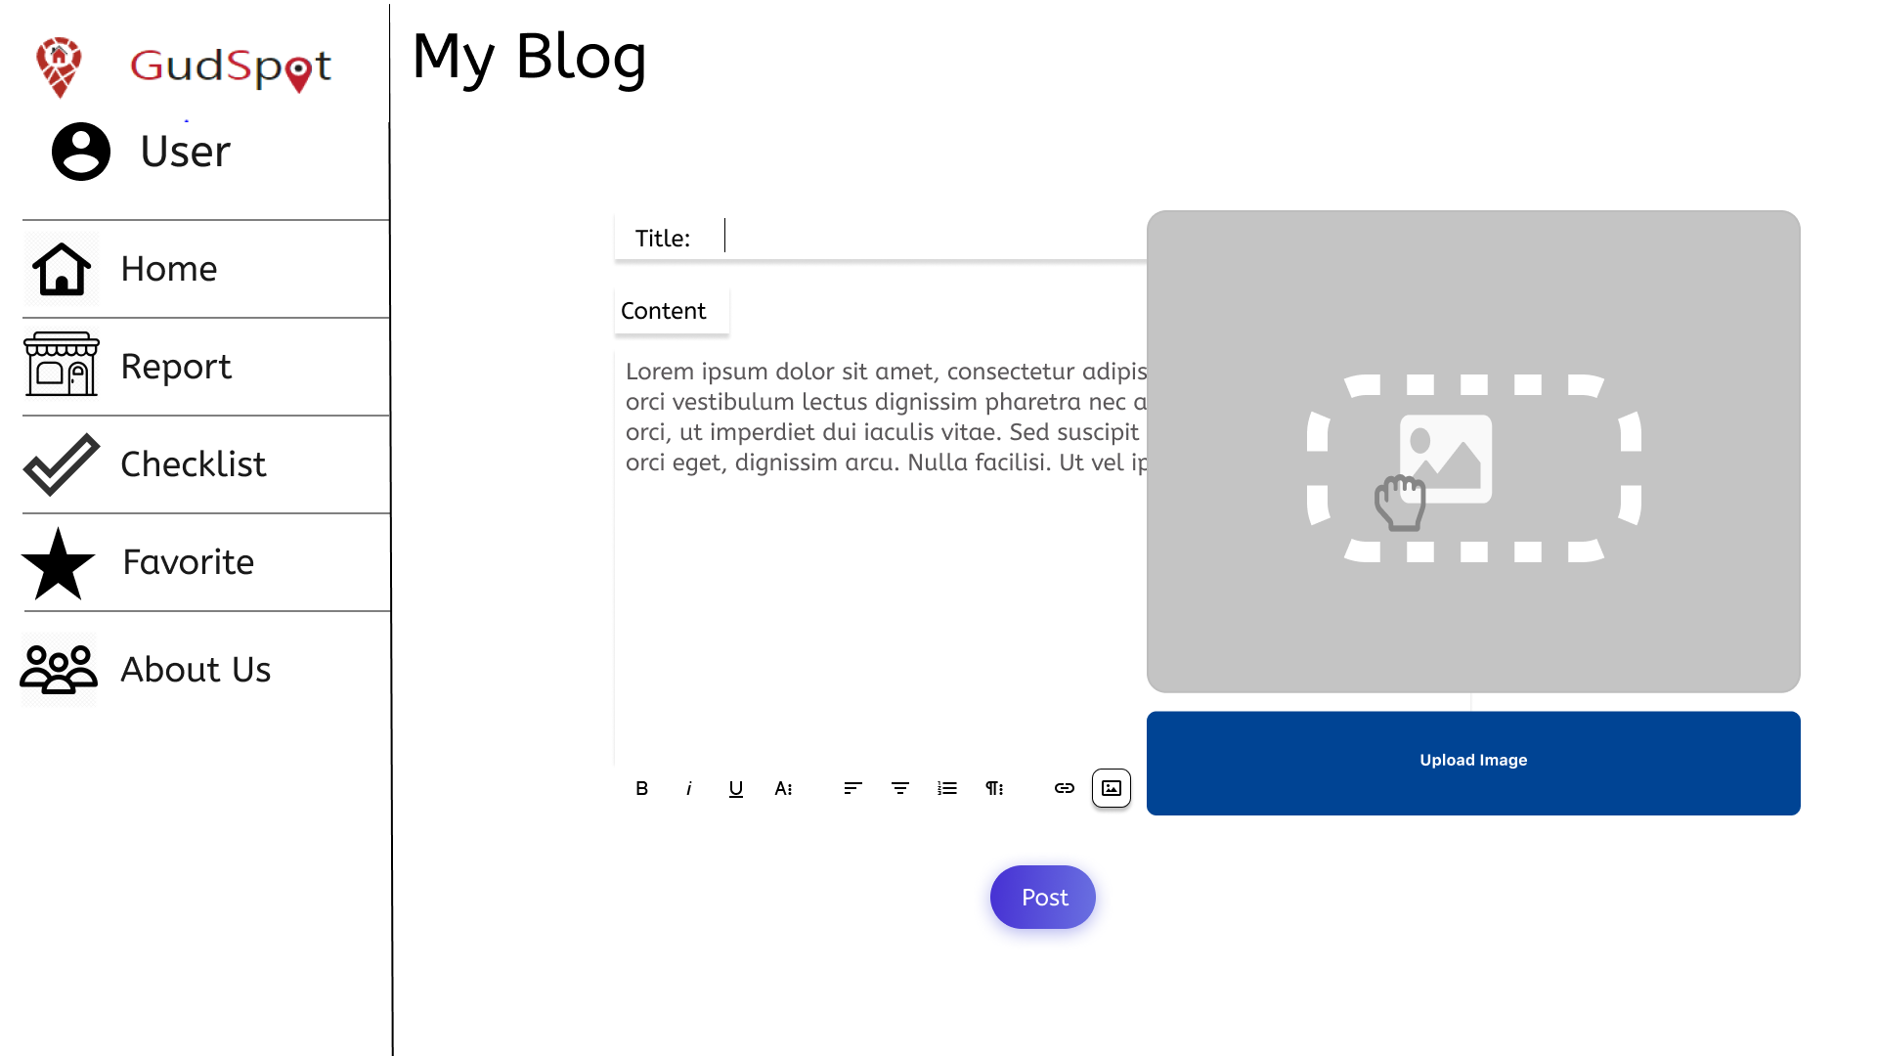

Upload image completed, show image on the content panel

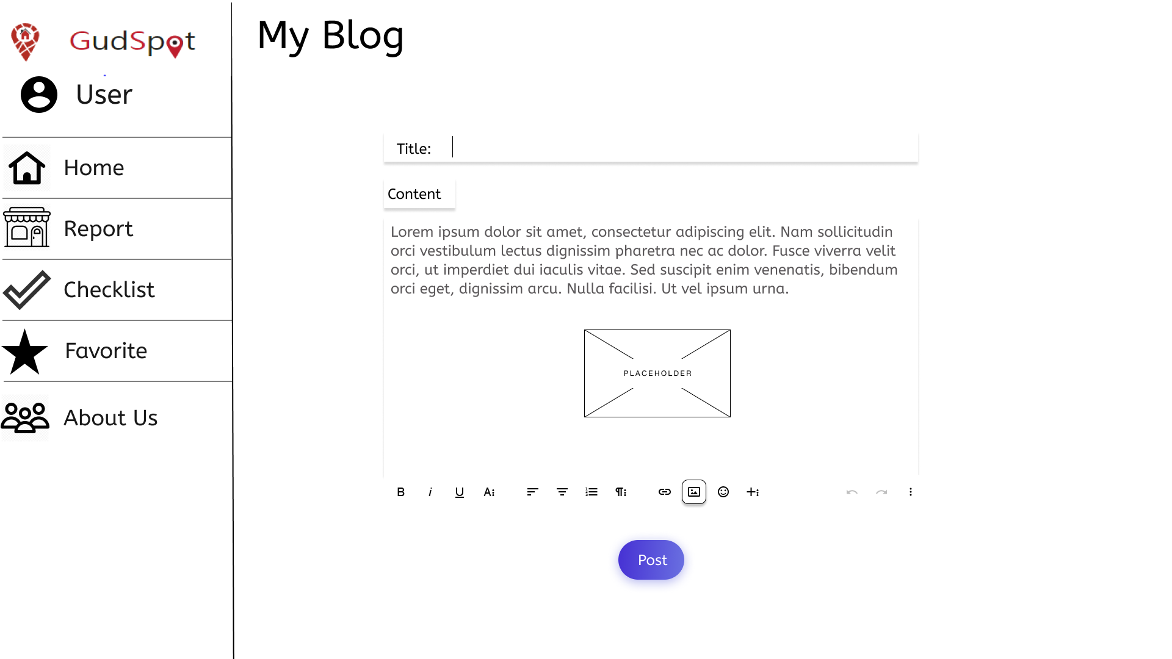

**12’/ Admin page**

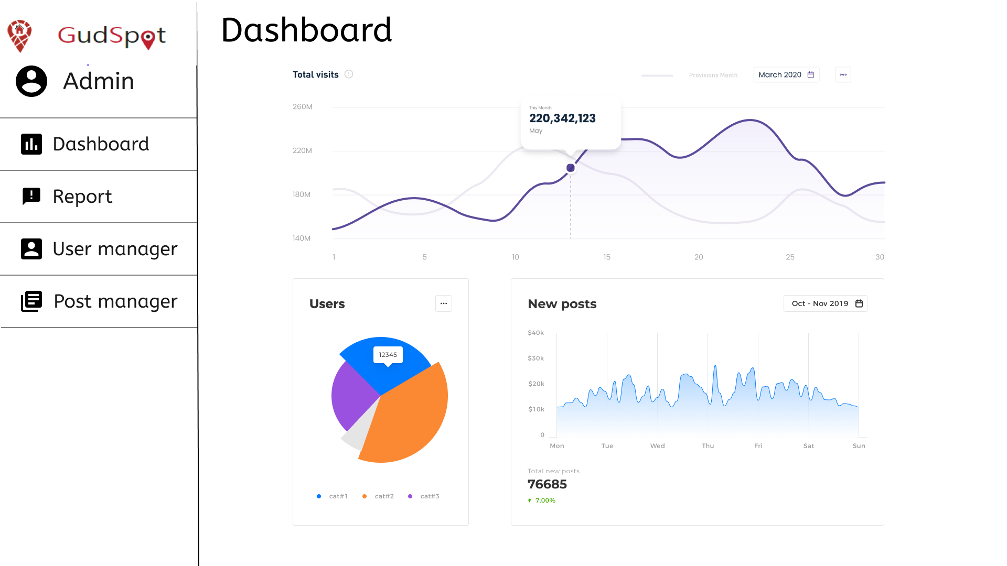

Dashboard provides statistics on the web site, including number of users each type, total visits, number of new posts

**12/ Ban user**

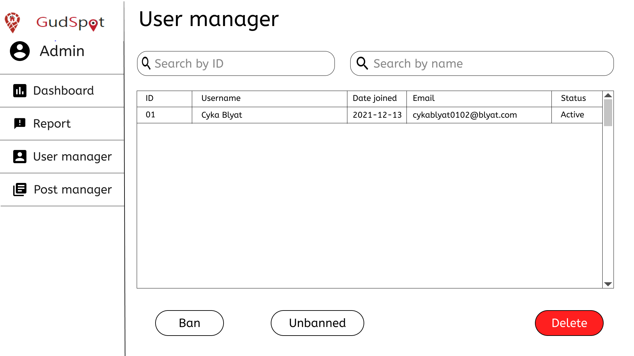

Display a lists of user with their status

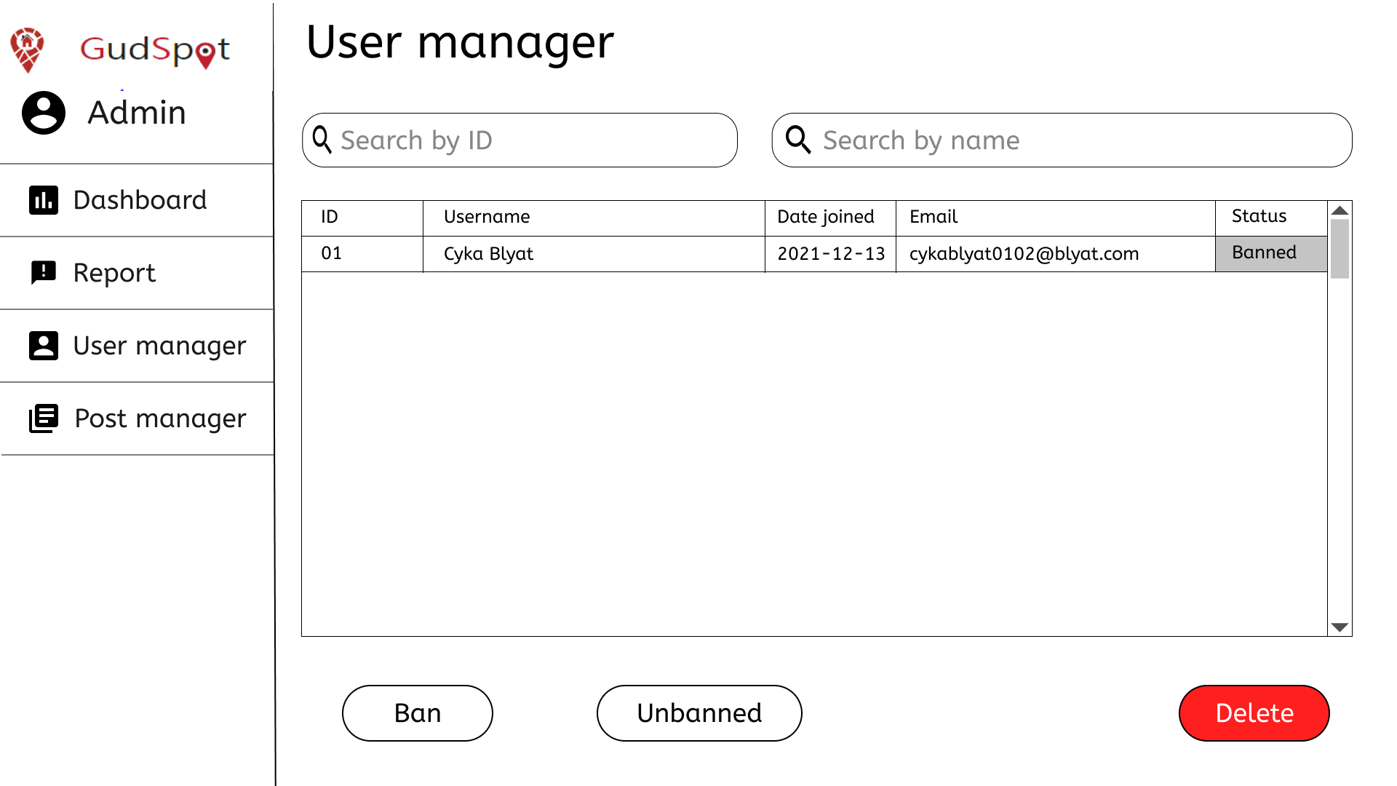

Banned users have their statuses changed

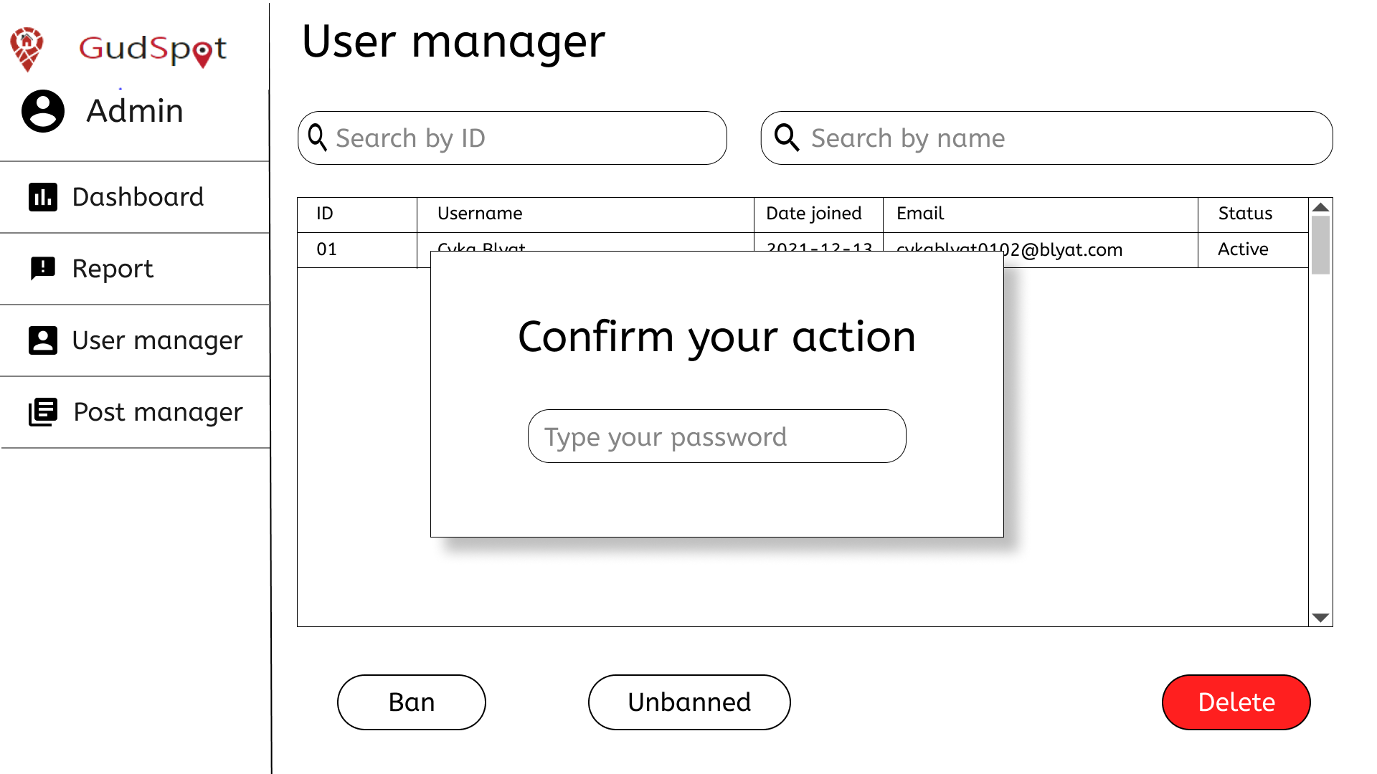

A confirmation box appears when there are actions toward users

**13/ Censor post**

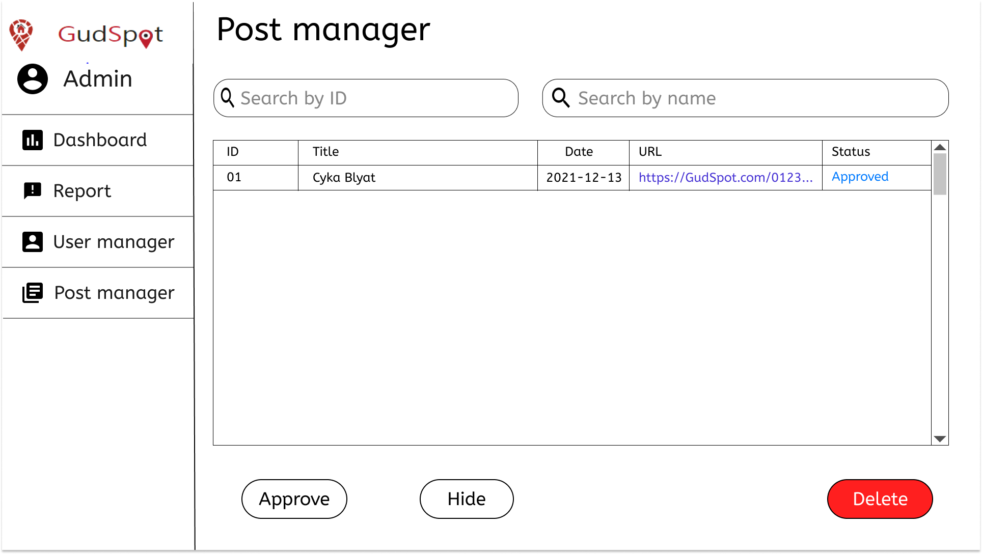

Display a list of posts with their status. Search bars used to search for posts by ids or names.

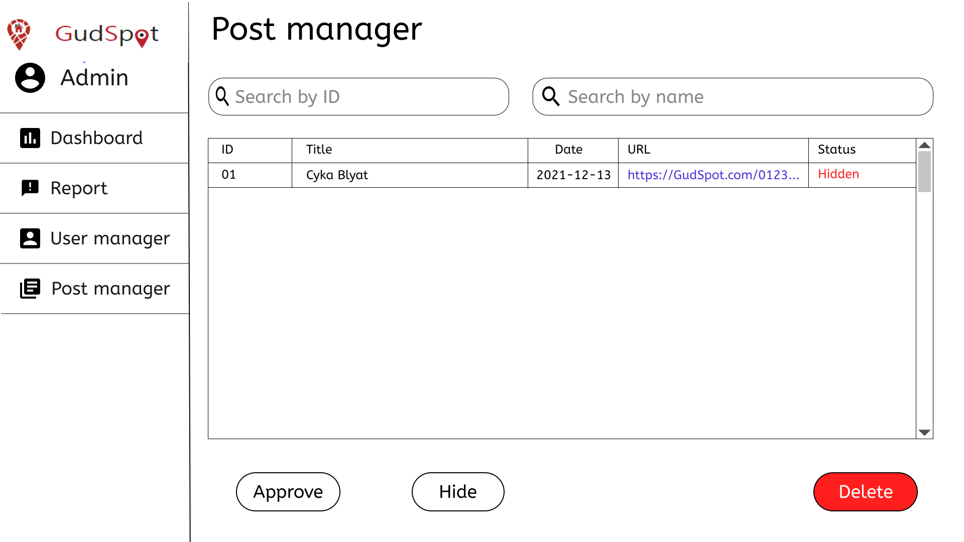

A post is hidden

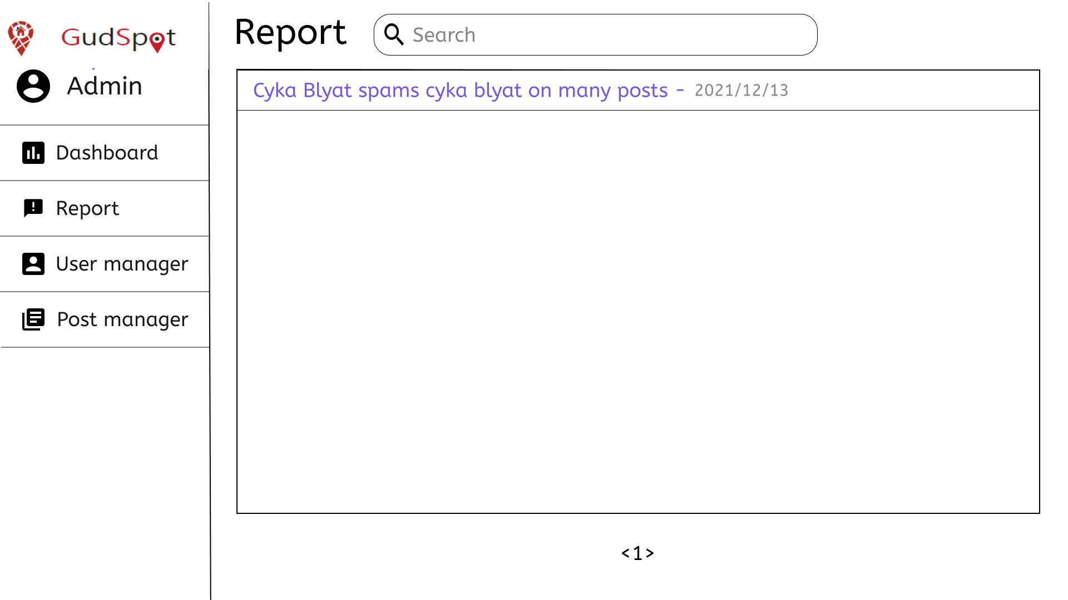

Display a list of reports provided by users about users or posts.

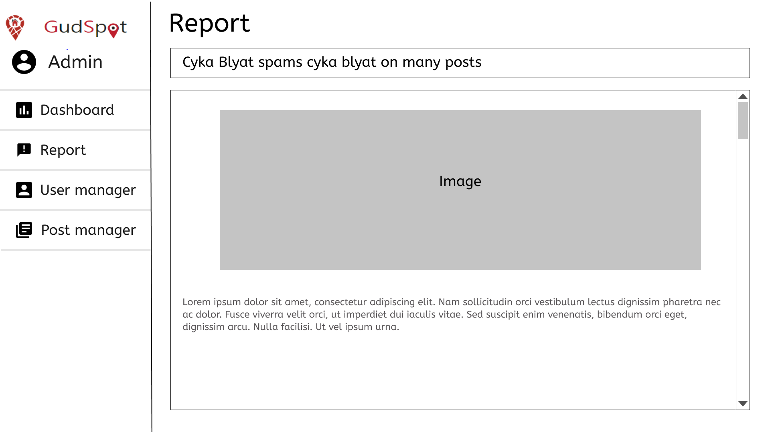

Details of a report

**14/ Delete post**



List of posts

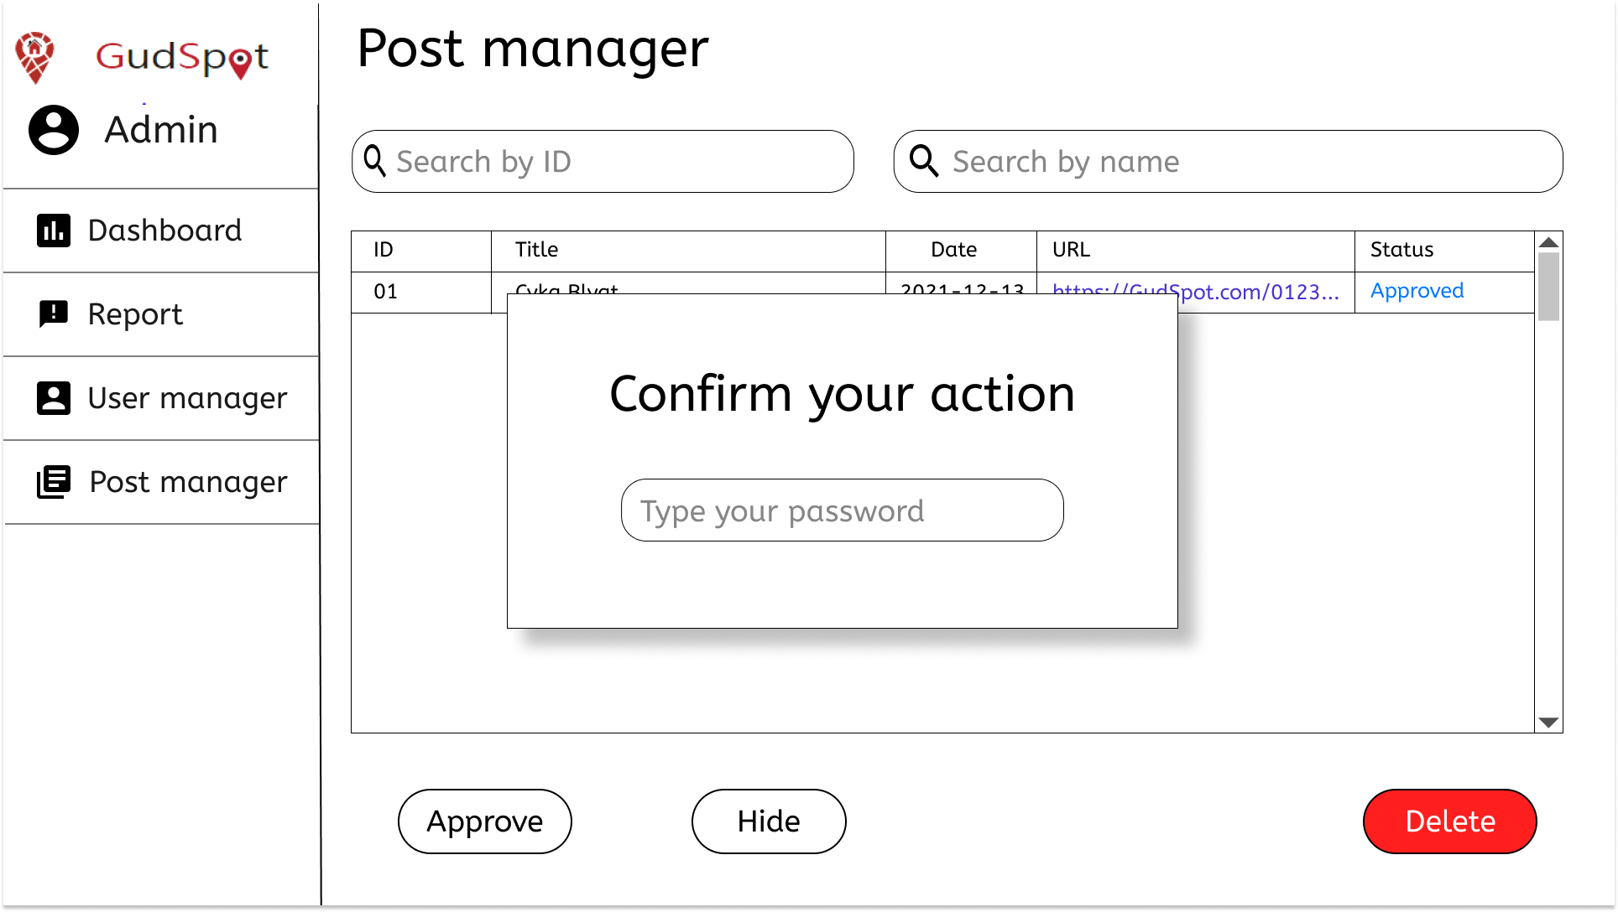

Deleting a post will display a confirmation box that requires a password to complete the action.

**15/ Export address to Google Map link.**

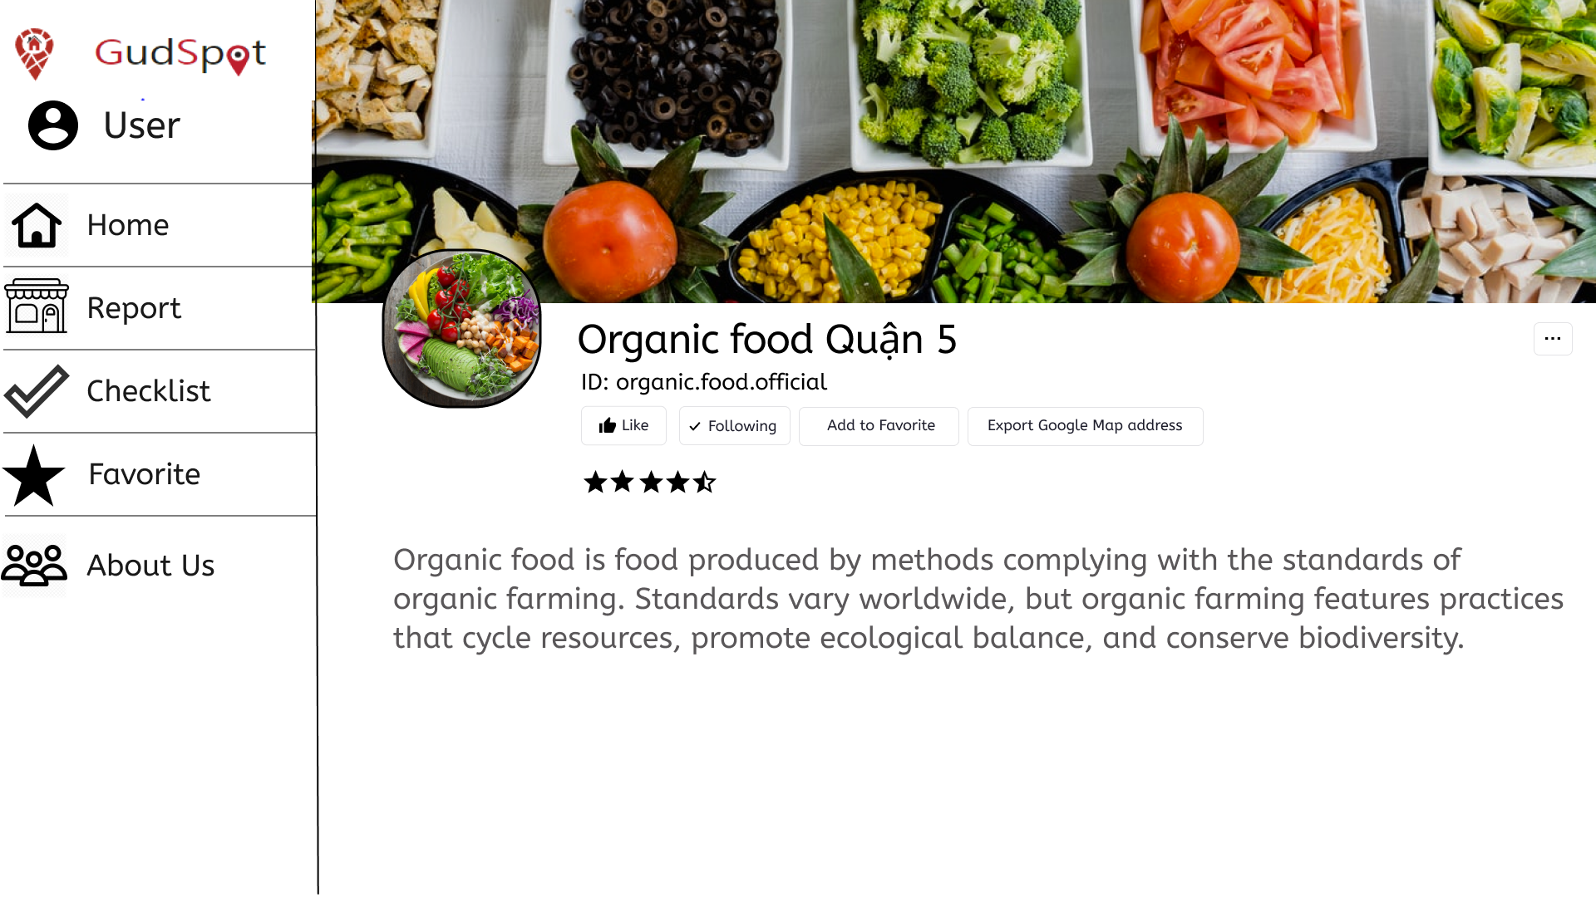

If you want to know the way to get to the spot you want, you can simply choose the Export Google Map address button to get the link of that place on Google Map.

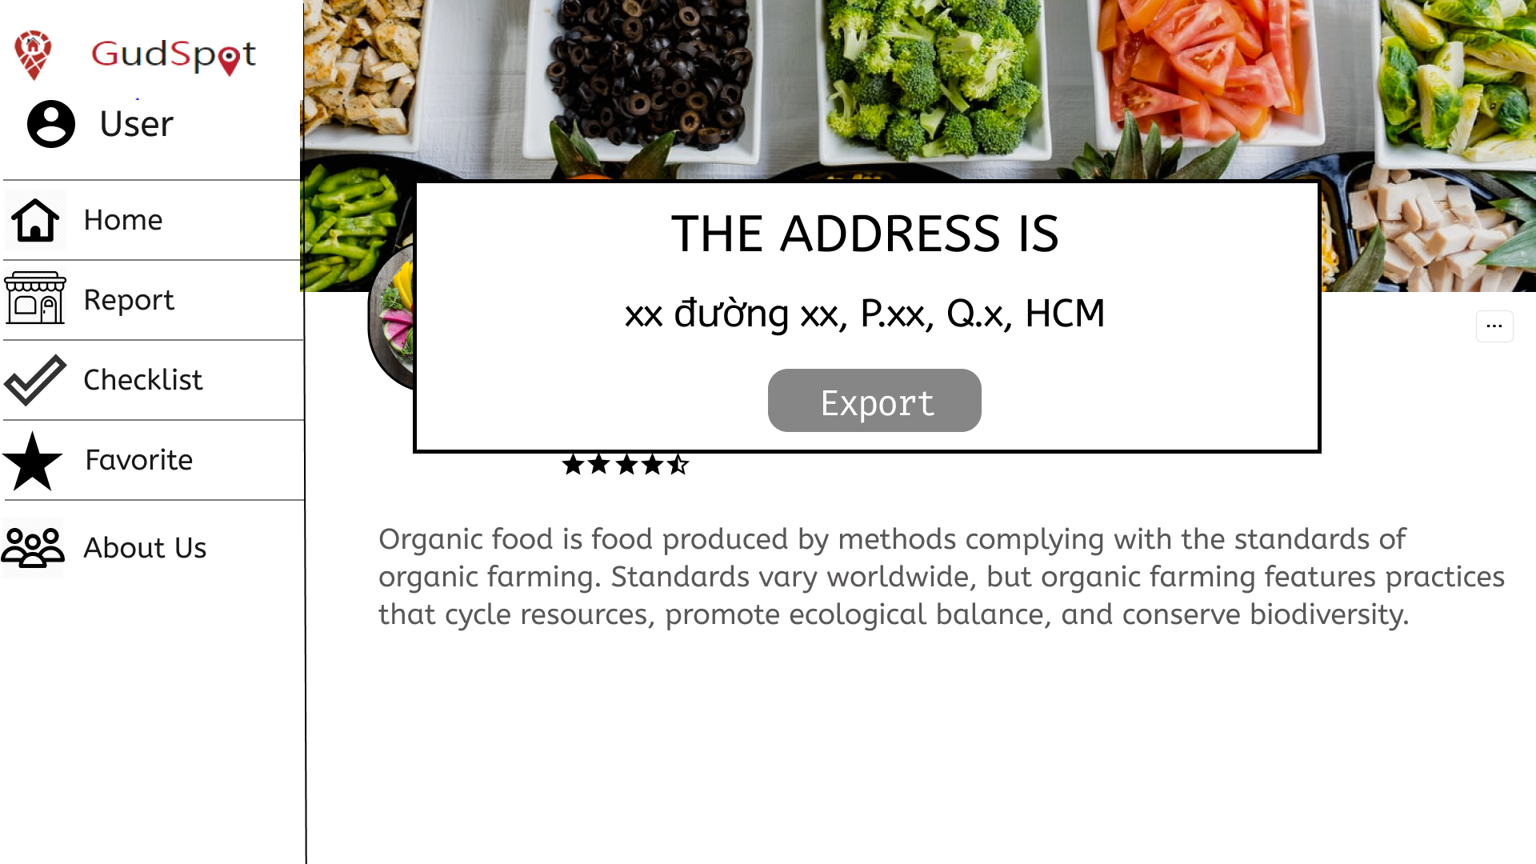

After you choose that button, Gudspot will show you the address of the place. Then you will click on Export to get the link

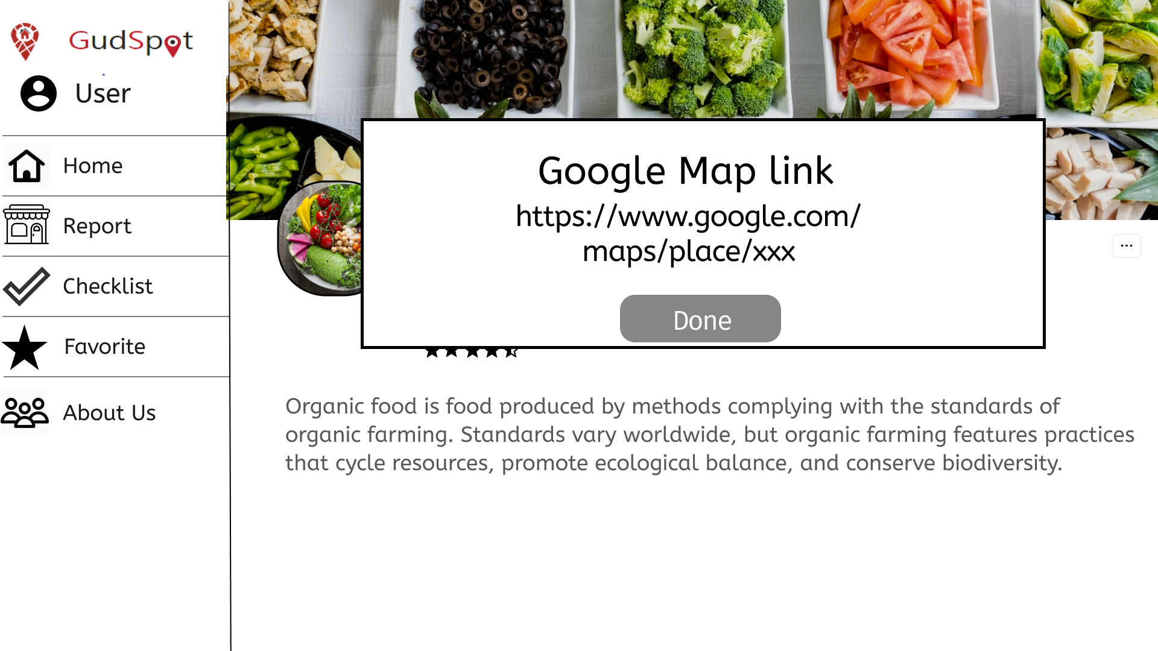

After you get the link, click Done to return to the main page